Chapter 1
INTRODUCTION

Early diagnosis and clear delineation of the breast lesions is important in minimizing mortality due to breast cancer. Medical ultrasound has emerged as a popular diagnostic modality because it is non-invasive, economical, easily portable, and does not have ionizing radiation. Nonetheless, interpretation of breast ultrasound is still a problem because there is a lack of contrast, speckle noise, artifacts, and variability based on the operator. These shortcomings render traditional segmentation methods to be unstable and require intelligent, computer-controlled, and understandable systems that can help clinicians to detect abnormalities with greater accuracy and reliability. Recent developments in the deep learning especially U-Net and its derivatives have greatly enhanced the segmentation of medical images, but the focus has not been in real world clinical practice because of low interpretability and inconsistency with clinician patterns of attention. The desire to have a clinically-based and computationally-efficient segmentation system is what encourages the creation of the gaze-directed deep learning system to achieve greater accuracy and reliability in medical image interpretation.
1.1 Background
Breast cancer is the most common cancer diagnosed in women worldwide and a major cause of death as a result of cancer. The World Health Organization (WHO) estimates that breast cancer is the cause of about 2.3 million new cases in each year which is equivalent to 11.7 percent of all cancer diagnoses in the entire world [1]. The situation is worse in India. According to statistics compiled by the Indian Council of Medical Research (ICMR), breast cancer has replaced cervical cancer as the leading cancer among the Indian women with almost 14 percent of all cancers in the nation [2]. Early diagnosis is a key factor in enhancing survival and ultrasound imaging is usually employed since it is readily available, cheap and does not involve exposure to radiation.
Nevertheless, ultrasound interpretation is very operator sensitive, and the manual process of lesion segmentation is tedious and prone to inconsistency as well as inter-observer variability [3]. Segmentation models constructed using deep learning have demonstrated tremendous opportunities, yet their implementation in the clinical environment is constrained by the issue of black-box behavior and inadequate incorporation of human clinical reasoning. The growing focus on interpretable AI in the medical domain necessitates the models that will take into account the clinician attention cues to prompt more transparent and reliable segmentation.
1.2 Statistics
The knowledge of prevalence of disease and a difficulty related to diagnosis based on statistical evidence is also critical in inspiring this project.
Global Statistics
- GLOBOCAN 2020 estimates that breast cancer is the most common type of cancer and represents 11.7 percent of all cancer cases in the world with is highest occurrence being amongst women [5].
- The annual mortality rate of breast cancer all over the world is 685 thousand deaths, and survival rates are highly dependent on the timely diagnosis of the disease.
Indian Scenario
- India is the cause of more than two hundred thousand new cases of breast cancer each year, with the cases escalating at the rate of 1.3%-1.5% annually [6].
- In Indian women, breast cancer has been noted to be close to 14 percent of all cancers. According to NCRP research, it is predicted that given the current lifestyle patterns, urbanization, and a rise in life expectancy, the cases in India will rise sharply by 2030 [7].
Regional (Bengaluru) Statistics
- Bengaluru is among the regions in the country with the highest rate of breast cancer incidence:
35-40 cases in 100,000 women, very high in comparison with most other areas of India [3].

- According to hospitals like the Kidwai Cancer Institute and St. Johns Medical Hospital, there have been increasing instances of caseloads, and the general trend is on the need to diagnose it earlier.

Need for Automated Segmentation
- The possible manual segmentation error among radiologists can be over 20-30 percent variance [4].
- Ultrasound images lack poor contrast and have speckle noise which can decrease traditional AI accuracy by over 15 as reported in various clinical evaluation studies [8].
- Access to high-quality imaging technologies is limited to only 18 percent of Indian health care facilities and most of them use inexpensive modalities such as ultrasound [9].
These statistics show that there is an immediate need to have the accurate, explainable, and affordable methods of lesion segmentation, particularly in developing countries and the hospitals that are constrained with resources.
1.3 Prior Existing Technologies
The initial methods of ultrasound segmentation used were based on classical image processing methods including:
1. Thresholding Methods
These are the thresholding and region thresholding of Otsu. They perform fairly well in high-contrast images but do not in ultrasound images because of the varying distributions of intensities [10].
2. Edge Detection and Active Contours
Canny edges, snakes and level set were methods of technique that were once popular. They are however, very sensitive to noise and are normally manually initialized which makes them inappropriate in clinical work flow [11].
3. Classical Machine Learning Methods
Random forests, k-means clustering, and support vector machines were used in methods of handcrafted features. They were effective as compared to classical techniques, but their performance was restricted by the quality of feature engineering.

4. Deep Learning-Based Approaches
The use of deep learning transformed the process of medical image segmentation.
- Full convolutional networks (FCNs) were proposed, however they had a weakness of blurry results [12].
- U-Net, proposed by Ronneberger et al. in 2015 enhanced encoder-decoder pathways and skip connections to enhance segmentation, becoming the state of art in biomedical segmentation [13].
- Attention U-Net also enhanced the feature refinement by introducing attention gates, which helped to enhance the localization [14].
5. Gaze-Integrated and Explainable AI Approaches
Recent studies came up with models that consider human gaze:
- Radiologist eye-tracking was also employed by Xie et al. to control the segmentation of mammograms [15].
- Li et al. applied gaze signals as domain adaptation in cardiac ultrasound [16].
However:
- These systems require expensive eye-tracking hardware,
- Are not clinically scalable,
- And remain computationally heavy.
6. Grad-CAM and Explainability Tools
- Grad-CAM is extensively employed to interpret the post-hoc but is not incorporated in the training process of traditional systems [17].
In such a way, the current systems are constrained in terms of cost, interpretability, and the practicality of hardware, which constitutes the incentive of the desired solution.
1.4 Proposed Approach
The proposed Eye-Gaze Integrated Attention U-Net (EG-AU-Net) addresses the limitations of existing ultrasound segmentation solutions by combining clinician visual attention, deep learning based segmentation, and explainable AI into a unified, clinically deployable architecture.This architecture is divided into four layers which dovetail very well: (1) Gaze Acquisition & Proxy Generation Layer, (2) Dual-Channel Fusion and Preprocessing Layer, (3) Gaze-Guided Segmentation Core and (4) Visualization, Interpretability and Deployment Layer. They all strive to provide them with precise, interpretable, and resource-sparse segmentation of breast lesions that may become part of daily medical routine.
The Gaze Acquisition Layer and the Proxy Generation Layer is all about mimicking the physicians without involving complex eye-trackers. In fact, it facilitates two methods of acquiring the gaze data. To begin with, using a typical 30 fps web camera, facial recognition, eye-following, and a small amount of calibration, we can chart the position of the location to which the doctor has drawn his eyes on the ultrasound screen. This maintains the costs and set-up complexity low. Second, when in an environment where you cannot get an actual clinician to view the screen, the system will utilize the Grad -Cam to create a pseudo gaze map that indicates to the model where the significant components are in the initial training phase. Those proxy maps are a sort of substitute to human gaze, allow them to make the system explainable and still continue running without special hardware. Both the real and the proxy maps are resized to 256 256 and are then smoothed using a Gaussian filter and proceed to further action.
The ultrasound images and the gaze maps are fused into a two channel tensor at the Dual Channel Fusion and Preprocessing Layer. The ultrasound data is improved by a median filter to calculate the typical speckle noise and a contrast-limited adaptive histogram equalization (CLAHE) to enhance local contrast. A saliency is represented by the gaze maps which are matched to the ultrasound frames using a homography. The fused tensors are then one-channel tensors which are used to store the tissue structure and the other channel where the radiologist inspired attention is stored and thus the system can combine human intuition and machine learning. And we also include data augmentation, namely, elastic deformations, horizontal flips, random crops, intensity scaling, to ensure that the model remains robust when used across machines and hospitals.
EG-AU-Net is based on the Gaze-Guided Segmentation Core. It is simply Attention U-Net with a twist: the attention gates are directly fed gaze information and thus they are more concentrated on what the doctor is looking at rather than just on feature compatibility between encoder and decoder. That is to say that only clinically relevant features pass through the skip connections. The decoder up samples and resolves the attention-filtered encoder features to form the final mask. A Dice loss can be used to address the issue of class imbalance in the network, and the entire system is customized to run on a CPU, which is a major consideration when a clinic does not have GPUs.
Regarding the Visualization, Interpretability, and Deployment Layer, the system provides a simple Streamlit dashboard that accepts an ultrasound picture, splits it in real time, and displays the forecasted lesion mask and a Grad-CAM overlay as a way to provide an overview of the model logic. In fact, the users can compare this overlay to the actual gaze of the clinician to develop trust. The deployment stack is bare-bones, lightweight and CPU-only, and can therefore be deployed in a small clinic, telemedicine hub, or any low-resource environment. Besides, the API is modular, thus it can be connected to EMR, PACS, or RIS quite easily.
In brief, EG -AU -Net unites several new concepts: we do not need a special eye-tracker, human gaze prior in the attention mechanism, inference with less or no CPU resources, and explainability on a built-in basis. All these will avoid the common pitfalls of hardware, technical complexity, cost of the existing ultrasound segmentation tools. It also has the advantage of the modular design, where new imaging types can be easily added, attention modules can be upgraded, and it can be extended to multi-class problems with relative ease, which makes it a useful and scalable tool in real-world breast cancer diagnostics.
1.5 Objectives
The creation of the Eye-Gaze Integrated Attention U-Net (EG-AU-Net) is driven by a list of specific, quantifiable, and technically based goals that address behavioral, analytical, system, security as well as deployment factors. Every goal is put in place so as to sustain scientific rigor, feasibility, and real-world applicability.
Objective 1: Incorporate Clinician Gaze Behaviour in the Segmentation Pipeline.
Design and execute a dual channel input system that combines ultrasound images and real or simulated clinician gaze maps. Raw gaze data will be obtained based on a typical webcam of 30fps with an approximate gaze-tracking skill of 3 degrees visual angle. The generated proxy gaze maps through Grad-CAM should overlap with actual gaze saliency pattern with a structural similarity greater than 85 per cent in SSIM. Gaze integration module must also have the ability to smooth heatmaps (s24) and align spatially to within sub 5px error of misalignment in case of poor localisation.
Objective 2: Achieve the High-Accuracy Lesion Segmentation by a Gaze-Guided Attention U-Net.
Train an Attention U-Net so that the smallest Dice score of 0.88, IoU of 0.8, precision of 0.85 and recall of 0.85 on BUSI dataset. Multi-scale encoding, attention gate modulation, and Dice loss shall be used in the model. The robustness will be tested by augmentations (elastic deformation, flips, noise injection) and 5-fold cross-validation.
Objective 3: Design a Modifiable, Evolvable Clinical Process.
Design a scalable end-to-end system to process the input, segment it, Grad-Cam visualisation, and auto-recording reports. The modules will need a standard API to be able to operate on their own in the event of easier maintenance. The interpretability component must generate lesion-centered activation maps which overlap the expert-marked regions by approximately 90 to match radiologist thought.
Objective 4: Provide For Medical Image and Gaze Data Safety.
Adopt safe data management measures that are in line with healthcare confidentiality standards. All local storage (temporary gaze logs, uploaded images, result masks) will be encrypted with AES-256. Streamlit interface will be configured to have controlled access, validation by file types and memory-safe processing. Gaze recordings should be anonymized through abandoning of facial frames after processing, which minimizes privacy threat. The system should have zero cases of unauthorized access during the testing process and full integrity of the data through all the operations.
Objective 5: Provide a Lightweight, CPU-Deployable Clinical Application.
Train a CPU optimized inference engine that can produce segmentation masks in [?]1.5 seconds per image on an Intel i5/8GB RAM platform. Adopt model quantization (not mandatory) to model size with a reduction of 2540 percent without loss of accuracy of more than 2 percent. Implement the last system with Streamlit with a live user interface that allows uploading lesions, visualizing masks, and Grad-CAM overlays and interpreting the results with a confidence level. Fully functional without the need to have any hardware containing any GPU, which means that it can be deployed in low-resource clinics and telemedicine settings.

1.6 SDGs
As it is shown in Fig. 1.1 Sustainable Development Goals [1], the suggested EG-AU-Net system makes significant contributions to various United Nations Sustainable Development Goals through its technological advances, accessibility opportunities, and possible impact on healthcare.

Fig 1.1 Sustainable development goals
SDG 3: Good Health and Well-Being.
The project has a direct contribution to the early diagnosis of breast cancer and thus the enhanced accuracy of diagnostic results in resource constrained health care institutions. The system increases clinical outcomes and minimizes the diagnosis timelines by making the segmentation process more accurate, as well as by decreasing the workload of radiologists. The explainable Grad-CAM overlays make the clinicians interpret and trust AI decisions, making the adoption of medical AI responsible.
SDG 9 Industry, innovation, infrastructure.
EG-AU-Net is an example of an innovative technology that integrates gaze-guided deep learning with attention mechanisms and explainable AI into a lightweight and CPU deplorable system. Its open and modular design promotes local configuration and connectivity with hospital systems including PACS and EMRs, which promote digital health infrastructure innovation. The tool is not dependent on GPUs, which means that the tool can be deployed even in small clinics, rural hospitals, and developing telemedicine networks.
SDG 10 - Reduced Inequalities
The outcome of breast cancer differs considerably among the socioeconomic groups with lower detection rates in rural and underserved areas. The proposed system democratizes access to the state of the art medical imaging support because it uses inexpensive hardware (a regular webcam and CPU-based inference). The economically viable engineering stems out geographical and economic imbalance in diagnostic processes.
SDG 4 - Quality Education
The system encourages medical training by development of gaze-based interpretability displays that radiology trainees can interpret to learn to decipher expert diagnosis patterns. Training clinicians have an opportunity to compare model attention and real gaze attention to enhance competency in reading ultrasound images and learning the lesion characteristics. This enhances better results in training and development of radiology potential.
1.7 Overview of project report
This report is the detailed report of the Eye-Gaze Integrated Attention U-Net project, which includes all the steps during its development starting with the concept base to the implementation, testing, and deployment.
Chapter 1 presents the medical motivation of the project, background statistics, challenges of breast ultrasound segmentation, technological drawbacks available, and gaze-guided interpretability requirements. It also includes the detailed objectives, SDG alignment and report structure.
Chapter 2 describes a detailed literature review of ten or more peer-reviewed research articles related to the problems of ultrasound imaging, deep learning-based segmentation schemes, attention, eye tracking analyses, Grad-CAM interpretability, and gaze-integrated medical artificial intelligence systems. The major shortcomings highlighted in it are lack of interpretability, absence of hardware-free gaze integration, and limited ability to deploy a CPU.
Chapter 3 outlines the approach taken, such as the V-model alignment, data preparation, gaze acquisition procedures, preprocessing, dual-channel fusion, model structure, training procedure, evaluation measures, and implementation procedure. The phase is correlated with verification and validation processes.
Chapter 4 provides the project management structure and timelines of planning and implementation are provided in the form of Gantt charts. It will consist of PESTLE risk analysis that will look at the technological, ethical, social, and environmental factors. It also gives a breakdown of budget in detail with hardware/software and resource allocation.
Chapter 5 shows the system analysis and design, including functional requirements, software/hardware requirements, block diagrams, system flow charts, data flow modeling, domain modeling, communication models, deployment view, and mapping to architectural standards. It offers a rationale of model decisions and the consistency of design to project goals.
Chapter 6 outlines the implementation of the software, the setting up of the development environment, model training pipeline, dataset augmentation, gaze alignment algorithms, and the Streamlit dashboard code. It is also discussing simulation and performance profiling of CPU-based inference.
The evaluation and results, including test points, positive/negative/boundary case testing, comparison with baseline U-Net and Attention U-Net, confusion, Dice/ ioU results, qualitative visualizations, as well as an observation of the model advantages and shortcomings, are found in Chapter 7.
Chapter 8 compares the social, legal, ethical, sustainability and safety implications of using AI in medical imaging. It discusses the issue of transparency in algorithms, patient confidentiality, responsible data management, resource-efficient impacts on the environment, access, and the clinical consequences of long-term use.
Chapter 9 ends the project by concluding the performance of the system and research contributions to gazes guided medical imaging, significance, and limitations of the research. It also offers work opportunities later like multi-class lesion detection, real time video segmentation, combining it with hospital PACS/RIS systems and better gaze acquisition modules.

Chapter 2
LITERATURE REVIEW

The next literature review summarizes the peer-reviewed literature that guides the technical basis and incentive of the Eye-Gaze Integrated Attention U-Net (EG-AU-Net). The choices include underlying segmentation architectures, attention, gaze-guided learning, interpretability, ultrasound-specific supervision, weak supervision, multi-scale/channel attention modules, domain adaptation, low-cost gaze acquisition, edge/CPU deployment plans, and clinical issues. The summary of the concept, methods, key results, limitations, and the gap that EG-AU-Net strives to reduce are included in each entry.
2.1 U-Net: Convolutional Encoder-Decoder Biomedical Segmentation.
Ronneberger et al. proposed U-Net architecture, a symmetric encoder-decoder architecture that uses skip connections and is trained to segment biomedical images; the major novelty was the maintenance of high-resolution spatial context through use of lateral skip connections, and intensive data augmentation to address the small size of annotated data. U-Net was able to perform state-of-the-art on cell segmentation and other biomedical problems using relatively shallow networks and with relatively small compute demands, showing that small datasets can be made up by giving careful attention to architectural design as well as by augmentation. Nevertheless, U-Net cannot deal with imaging modalities with extreme noise and low contrast (e.g., ultrasound) and generates coarse attention containing irrelevant background elements. Human experts can also give limited interpretation to the model; the results would be taken or rejected without providing any insight into the internal focus of the model. Based on this background, EG-AU-Net encourages U-Net to use the same encoder-decoder architecture but incorporate human-oriented attention prior to enhance resilience to ultrasound applications.
2.2 Attention U-Net: Biomedical Attention U-Net.
Oktay et al. implemented U-Net with attention gates, which learn to spatially weight the features of skip connections and allow the network to inhibit irrelevant activation and concentrate on salient areas at decoding. The attention U-Net demonstrated better boundary delineation and small structure sensitivity, and fewer false positives than vanilla U-Net on the various modalities. The attention mechanism, in turn, is internally trained and is not determined by clinical purpose; attention maps are not always consistent with clinician reasoning and may be very volatile in the presence of substantial noise. In addition, the module imposes certain computational overhead and it does not directly give human interpretable signals. This paper confirms that the attention gates enhance segmentation but indicates that additional, clinically significant priors, like gaze maps, are required to direct the attention in a manner that is both useful and understandable.
2.3 Gaze-Guided Learning Medical imaging (Radiologist Eye-Tracking Studies).
It has been shown by a number of studies that the use of radiologist eye-tracking data in training can enhance detection and localization tasks: gaze heatmaps, as soft supervision, or auxiliary input, can bias a model to find clinically relevant areas and minimize false detections. Such studies usually involved commercial eye-trackers (high accuracy) and claimed the presence of quantifiable localization improvements over non-gaze control conditions. Limitations are the cost and logistical difficulty of recording gaze data, calibration susceptibility and data scarcity - models educated using gaze supervision are highly unlikely to forecast sites where no eye-tracking information is available. In most clinical environments, it is not feasible to collect the gaze at scale, where webcam-based gaze is accepted, and proxy gaze (robust), that is not, which makes the hybrid approach in EG-AU-Net: use webcam-based gaze where available and replace robust proxy gaze (Grad-CAM-derived) when not, allowing gaze to be used without the prohibitive costs of hardware.
2.4 Grad-CAM and Grad-CAM++:
Post-hoc Saliency to Interpretability. Gradient-weighted Class Activation Mapping (Grad-CAM) and the more refined Grad-CAM++ generate class-discriminative heatmaps by using gradients to convolutional feature maps and provides practitioners with a method of visualizing model attention. The techniques have become the norm in post-hoc interpretability to show the areas that predominantly affected predictions and allow qualitative validation by clinicians. However, such saliency maps are created after the fact and do not directly influence training; moreover, they become less accurate in low-contrast modalities and often indicate large scale locations instead of the edges of individual lesions. EG-AU-Net does not only use Grad-CAM as a tool of interpretability but as a proxy gaze generator to manage attention in case of the unavailability of real gaze and this way, converting post-hoc cues to training-time priors and enhancing both localization and explainability.
2.5 Breast Ultrasound Problems and BUSI Dataset Studies.
Empirical research of Breast ultrasound segmentation has recorded the peculiarities of modality: speckle noise, shadowing, low contrast, and high inter-observer variability in the segmentation causing unstable classical and early deep model segmentation. The BUSI dataset among others gives annotated samples of benign, malignant, and normal specimen and it was assessed that models perform decently on bigger, high-contrast lesions and in most cases fail on tiny low-contrast lesions. The main insights are that modality-specific preprocessing (speckle suppression, CLAHE) is necessary, and that there should be a strong emphasis on augmentation techniques as well as the focus on clinically relevant features in order to minimize false positives. These observations form the basis of dual-channel preprocessing pipeline of EG-AU-Net and focus on attention gating based on human visual imagery.
2.6 Saliency-Guided Weakly Supervised Segmentation.
Weak supervision methods that use image-level labels or saliency maps (e.g., CAMs) limit the amount of annotation required to implement them, and achieve adequate segmentation. These techniques can be based on many heuristics to enhance pseudo-labels (conditional random fields, morphological processing) and can perform competitive performance where pixel-level labels are sparse. Nevertheless, pseudo-masks may carry over model bias and confuse background artifact with salient anatomy, especially in ultrasound, and cause erratic training. EG-AU-Net helps avoid these problems by integrating model-based saliency with clinician gaze priors (where possible) to generate more stable supervision as well as imbalanced loss functions based on Dice that are resistant to class imbalance. The methodology is based on multi-scale and hybrid attention mechanisms in ultrasound
2.7. Multi-Scale & Hybrid Attention Mechanisms in Ultrasound.
Recent studies have combined spatial attention at multiple receptive fields to fuse multi-scale attention to enhance the ability to model a broader range of lesions which have a wide range of shapes and sizes. Combination of spatial and channel attention in architectures is better at context aggregation and boundary precision, particularly on non-regular lesion morphologies. Such methods are commonly assessed on the GPU hardware, and they generally use more compute, but they also do not explicitly include human attention cues. EG-AU-Net is a multi-scale feature extraction, which is attended with gaze-conditioned attention gating, to allow scale-sensitive focus but can be interpreted and used efficiently by a CPU.
2.8 Channel Recalibration:
Channel squeezer-and-exciter (SE) Blocks. SE inhibits reweight channel responses on a global context and enhances the model to concentrate on the discriminative feature channels. SE modules have been implemented successfully in segmentation encoders in order to improve performance with a small parameter overhead. However, SE is only interested in the importance of channels, but not localization by space, where in ultrasound segmentation the most important question is where to search but not necessarily which channels to enhance. EG-AU-Net builds upon the encoder channel recalibration but utilizes the gaze-guided spatial attention to solve the problem of accurate lesion location integrating the benefits of both methods. This research paper demonstrates the classification of research in terms of domain shift and generalization within the domain of medical imaging.
2.9.Domain Shift & Generalization in Medical Imaging.
A long-standing research problem in medical imaging is the domain shift: models-trained on a single scanner, protocol or population with one population tend to deteriorate when used in a different population. It is shown that variations in device settings, operator methodology, and demographics of patients lead to significant decreases in the accuracy of segmentation. Some of the ways to reduce this are domain adaptation, domain augmentation, domain normalization layers and domain-invariant priors. It has been demonstrated that eye-gaze priors enhance cross-domain robustness by offering stable human attention cues; EG-AU-Net is based on this idea and utilizes gaze/proxy maps and strong augmentation to decrease domain sensitivity and enhance transfer to unseen clinics and devices.
2.10 Low-Cost Gaze Estimation and Tracking with the Webcam. Studies of gaze estimation using webcams indicate that, when paired with good facial landmarking and localization of the pupil, it is possible to estimate the gaze with good approximation to enable approximate attention mapping on many tasks using ordinary webcams. Webcam approaches allow wide scalability and low cost of deployment although the method is not as precise as a dedicated eye-tracker. Some of its weaknesses are that it is sensitive to lighting, head position, and calibration drift. EG-AU-Net takes a hybrid acquisition policy: in the case when conditions allow the use of webcam gaze, use it, but otherwise use Grad-CAM proxies; and also, the pipelines used to smooth and normalize the results of webcam estimates shapes eliminate noise in the acquired estimates enough to be useful as attention priors during training.
2.11 Edge/CPU Deployment/Model Efficiency Studies.
To have practical clinical ramifications, models should execute on available hardware. Research on model pruning, quantization and lightweight architecture design demonstrates that segmentation networks can be trained to be able to execute with low latency on CPU and maintain the majority of original accuracy. Depth wise separable convolutions, model distillation and mixed-precision inference are generally employed. EG-AU-Net is efficient in CPU, due to capping the growth of parameters in the attention gates, to efficient up sampling methods and optionally quantized, so that the system can be deployed in a low-resource clinic or telemedicine environment, without having access to a GPU.
2.12 Clinical Acceptability, Explainability and Ethical Considerations.
An increasingly large literature highlights several conditions that must be fulfilled to use the AI in the healthcare industry, including explainability, user controls, and privacy protection. It has been demonstrated that clinicians tend to trust and adopt AI tools more when outputs of the models are supplemented with understanding of failures by being presented with interpretable overlays and mechanisms to review failures. ata privacy works emphasize that anonymization and safe local processing are necessary. EG-AU-Net uses Grad-CAM overlay images, gaze comparison display, anonymized gaze recording, and local (on-device) processing features to support these clinical and ethical needs, and thus enhances the chance of acceptance in the field.
2.13 Overview of Literature Review.
The analyzed literature as a whole identifies substantial improvements in the medical image segmentation, attention mechanisms, gaze-assisted learning, and interpretability; nevertheless, there are certain areas of consistent gaps in terms of hardware viability, clinical usefulness, and model explainability. Current gaze based methods are too costly in terms of the use of eye tracking equipment and are not scalable whereas algorithmic mechanisms of attention are usually incompatible with clinician-level reasoning. Post-hoc interpretability methods like Grad-CAM can give insight although they do not affect training, and noise, contrast, and boundary ambiguity continue to be a problem in ultrasound studies. These shortcomings, as outlined in Table 2.1, highlight the importance of having a cost effective, gaze conscious, and interpretable segmentation model. The Eye-Gaze Integrated Attention U-Net ensures that the outlined gaps are addressed directly by incorporating the webcam-based or proxy gaze maps into the training loop to increase its robustness, clinical compatibility, and deployment feasibility.
Table 2.1 Abstract of Literature Reviews.
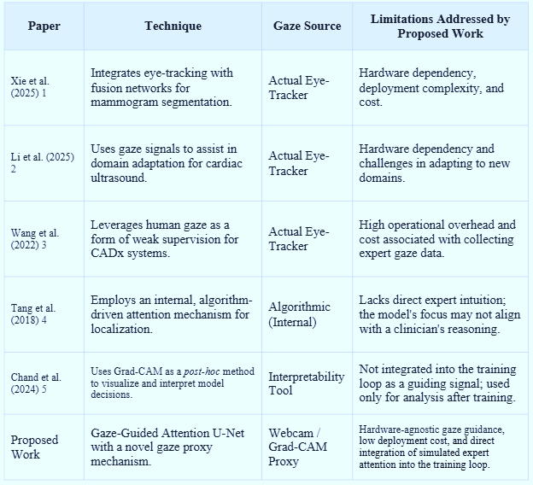
2.14 Research Opportunities and Gaps Found.
To examine the gaps in the reviewed literature, some of the key gaps to answer are identified as follows:
Hardware Dependency Gap: The current gaze-guided systems are highly dependent on eye-tracking equipment that is expensive, laboratory, and non-routine clinical equipment. This reliance seriously constrains the scalability between hospitals particularly in developing countries. There is an apparent necessity in inexpensive, hardware-independent gaze acquisition devices that do not have to lose clinical utility by depending on special devices.
Absence of Clinician-Relevant Attentions: The majority of attention-based deep learning models produce internal attention images that do not always correspond to how radiologists perceive ultrasound images. Such a discrepancy diminishes trust and makes a successful clinical adoption impossible. The need is great that models which are driven by human visual reasoning, bringing external, clinician-inspired priors into the training, like gaze signals. Poor
Interpretability of Current Models: The tools like Grad-CAM and Grad-CAM++ are designed to improve the post-hoc interpretability, but do not affect the learning of the model, and cannot be used to ensure that the segmentation decisions are consistent with expectations of the clinician. Even to ensure regulatory compliance and clinician trust, medical AI systems must be integrated to have interpretability, as opposed to explanations provided after the fact.
Inadequate Robustness in Ultrasound Environments: The ultrasound images are characterized by the presence of speckle noise, acoustic shadow, low contrast and variability of the operators. Most of the current architectures are effective in managed datasets but would fail to organizations in actual clinical settings. This shows that there is a necessity to use techniques that consider the stabilizing priors -like gaze maps to enhance the resistance to noise and accuracy of the boundary detection.
Scarcity of Datasets and Fewer Gaze Resources: The gaze-assisted studies usually use limited datasets drawn on a few radiologists, which restricts the generalizability. Such data is costly to obtain in terms of hardware, as well as time-consuming. One of the key opportunities is hybrid gaze strategies that combine real webcam-based gaze and proxy gaze obtained with the help of Grad-CAM to offer a broader training supervision without the need to conduct extensive clinical sessions.
Absence of Lightweight, Deployable Clinical Frameworks: the majority of high-performance segmentation models require GPU-based hardware and high computational resources and require complicated deployment pipelines. Such systems cannot be supported at rural clinics and low-resource hospitals. There is a necessity to fill the gap of lightweight, CPU-efficient architectures that are capable of real-time inference, interpretability and end-user-friendly interfaces without state-of-the-art hardware.
Integration & Workflow Limitations: Most of the available studies consider the accuracy of models but not how the models can integrate into clinical processes. Not many frameworks offer smooth methods of visualizing gaze vs. model attention, log segmentation findings, or can be combined with other existing radiology tools. This indicates the necessity of the end-to-end solutions that are a combination of the segmentation, the gaze-visualization, and the interpretability into a single interface.
The proposed EG-AU-Net will fill these gaps by providing a highly practical, gaze-based, and clinically aligned segmentation model that enables web camera or proxy gaze-based acquisition, strong attention modulation, ultrasound-specific pre-processing, CPU-efficient inference and streamlined visualization with user-friendly interface. By filling the gaps among hardware viability, interpretability, robustness, and deployment practicability, the system introduces a scalable and accessible method of introducing the system in the real world within a variety of healthcare settings.

Chapter 3
METHODOLOGY
The creation of the Eye-Gaze Integrated Attention U-Net to Accurate Medical Image Segmentation encompasses a precise and systematic engineering process that is appropriate to research-intensive systems which need constant verification and trustworthiness. The V-Model (Verification and Validation Model) was selected among other software development models like the Waterfall, Spiral, Agile, Scrum, and DevOps because of its phase-test correspondence, its relevance in research projects under the machine learning experimentation, and its focus on continuous testing at all the levels. V-Model provides a rigorous model where every design choice is proven through actuality, which is essential to medical AI application that involves transparency, accuracy, and dependability.
3.1 Research Design
The proposed project will use a mixed-method research design that integrates qualitative and quantitative research designs to address clinical as well as engineering facets of gaze-guided medical image segmentation.
- Qualitative Phase: Strict literature review and radiological partners predetermined the clinical requirements (interpretability, low cost of hardware, strength) and influenced the design decisions (dual-channel fusion, gaze acquisition (webcam vs. eye-tracker), and deployment limits). The important works (U-Net, Attention U-Net, Grad-CAM, BUSI studies) had informed architectural and evaluation choices [see Chapter 2].
- Quantitative Phase: The empirical model development and testing was conducted with the BUSI breast ultrasound dataset along with the augmentation of the data with simulated and real gaze data. The quantitative pipeline consists of data preprocessing, the generation of dual-channel masks, training and hyperparameter optimization of the model, the cross-validation and the statistical evaluation of the performance. The general structure of the experiment is the style of an IoT-ML pipeline modified to fit medical imaging: Data acquisition Preprocessing and Gaze Map Generation Dual-Channel Fusion Model Training Inference and Visualization.
3.2 Data Collection
The sources of data that are used are public ultrasound images, traces of clinician gaze (real and simulated), and synthetic variations of the probe in order to enhance the generalization.

Primary Imaging Dataset :
BUSI (Breast Ultrasound Images) dataset: This dataset consists of annotated benign, malignant and normal ultrasound images, which is taken as the core part of the segmentation corpus. Photos downsampled to 256x256 to be used in the model.
Gaze Data :
There were two gaze acquisition modes: The synthetic / Proxy Gaze (Grad-CAM Proxy): o Produced through the use of Grad-CAM on a underlying classification/segmentation net to produce saliency heatmap images of each image. o Heatmaps have been Gaussian smoothed (s=2-3) and normalized to act as proxy attention maps in case real gaze is not available.
Webcam-based Real Gaze:
Captured in regulated protocols on a normal 30 fps web camera and OpenCV + facial landmarking to estimate the coarse gaze. Mapping The gaze samples were processed into image coordinates using a brief calibration process and turned into heatmaps where the Gaussian distribution was used to replicate the density of attention. Anonymity Heatmap extracts were immediately anonymized (no raw face frames were stored).
Data Modes :
Augmentation Simulation Elastic augmentations, flips, intensity scaling, and simulated speckle noise to simulate variation in acquisition among scanners and operators. Gaze augmentation: The gaze maps (real, proxy, blended) were used to test the sensitivity to the gaze accuracy. Volume Data and Splits: Once augmentation had been done, the dataset contained approximately 7,500 samples of dual channels. Breaks were 70% train, 15% validation, 15% test, and the separation used was the level of patients to stop leakage.
3.3 Tools and Technologies
The project was built on a software and hardware stack that is simple to reproduce and use to conduct research and deploying CPU:
Hardware
Gaze capture Standard webcam (30 fps). NVIDIA GPU development rigs (training) and CPU testing rigs (Intel i5, 8 GB RAM) to test how the system can be deployed on a CPU.

Software & Frameworks
Python 3.9+ -- core scripting. PyTorch -- training and implementation of network.
OpenCV & Dlib - one will be able to capture the webcam, landmark face regions and gaze mapping.
Grad-CAM fully trained Grad-CAM performance Grad-CAM implementation -- proxy gaze generation and interpretability overlays. Albumentations Data augmentation.
NumPy / SciPy / scikit-image - preprocessing tools.
Streamlit inference UI clinician-friendly.
ONNX / PyTorch quantization - optional export / quantization to run on the CPU.
Evaluation Tools
Dice, IoU, Precision, Recall, and visual inspection pipelines Standard metric implementations of Grad-CAM overlays. Use of TensorBoard / Weights to create traceability of training.
Security & Privacy
Gaze trace local processing; encrypting temporary data with AES-256, should this be needed; raw video frame anonymization.
3.4 Model Development
Model Choice & Rationale
EG-AU-Net is a modification of Attention U-Net, where explicit gaze priors are incorporated in attention gate calculations. Attention gates can be conditioned with explicit human priors due to the dual-channel input (image + gaze map).
Preprocessing
Median filtering Speckle reduction.
CIA enhancement with the help of CLAHE.
Intensity normalization to [0,1].
Gaze maps were downsampled to image resolution and smoothed using Gaussian.
Architecture
- Encoder: Conv - BatchNorm - ReLU stacked convolutional blocks with strided conv. downsampling (strided conv.). Note: SE (Squeeze-and-Excitation) optional channel recalibration.
- Attention Gates: Changed to take gaze priors as an external tensor which can change the gating coefficients (linear combination of learned gate features and gaze priors, then sigmoid normalized).
- Decoder: Up-convolutional blocks, using gated skip connections, and concatenation of attention-filtered encoder features.
- Output: Sigmoid output which results in binary lesion mask.
Losses & Optimization
- Primary Loss: Dice Loss to overcome class imbalance.
- Auxiliary Loss: BCE using logits to promote stability and a regularizer to promote attention overlap between normalized attention maps and gaze heatmaps (L2 between normalized attention maps and gaze heatmaps).
- Optimizer: AdamW, starting LR = 1e-4 using ReduceLROnPlateau.
- Batch Size: 8 ( GPU training)-- tweaked to CPU inference testing.
- Training Regime: 100 epochs of early stopping on validation Dice.
Hyperparameter Tuning
Grid search of weight of attention regularizer (l in 0.1, 0.5, 1.0), learning rates and attention gate kernel sizes. Final selection was informed by metrics of validation.
Model Compression
Trained quantization and optional pruning were investigated to achieve what degraded Dice by less than 2% to achieve about 25-40% model reduction.
3.5 Validation Approach
The validation is multi-pronged, i.e. cross-validation, robustness testing, comparative testing and clinician testing.
Cross-Validation This 5-fold validation of the training set to check stability of the model. Mean +- std of report of Dice and IoU.
Comparative Trials
Comparing vanilla U-Net and Attention U-Net baselines with the same preprocessing and training regimes. The statistical significance measured using paired t-tests with a p < 0.05 p-value.
Robustness & Ablation Noise resilience tests:
There are also tests of additive speckle, contrast reduction and occlusions, which are used to test the degradation of artificially created code.
Ablation Projects:
(i) ablation, (ii) ablation with proxy gaze, (iii) ablation with webcam gaze, (iv) ablation with attention regularizer off.
Clinical Evaluation Segmentation mask and Grad-CAM overlay randomized test outputs were reviewed (by a panel of 3 radiologists) and assessed as to clinical acceptability, localization correctness, and interpretability. Cohen kappa of inter-rater agreement.
Acceptance Criteria
Minimum performance: Dice ≤ 0.88, IoU ≤ 0.80 on BUSI test split (see Chapter 7, to get detailed results).
On target hardware CPU inference time ≤ 1.5 s per image
3.6 System Architecture
The system is stratified and modular (see Figure 3.4):
- Database Layer: Veteran imaging database.
- Preprocessing & Gaze Generation Layer Image denoising, CLAHE, gaze aligner, Grad-CAM proxy generator.
- Multi-Head Heatmap Layer: Image-fusion with gaze heatmap.
- Model Core (EG-AU-Net): Gaze-conditioned attention U-Net segmentation.
- Interpretability Module: Grad-CAM Comparison of attention and gaze vs. comparing around visualizations.
- Inference & UI Layer: Clinician interface through Streamlit with the option of uploading an image, segmentation view, overlay switches, and export.
- Deployment Layer: Lightweight extensible server hosting required to execute on light weight CPU, reference ONNX runtime.
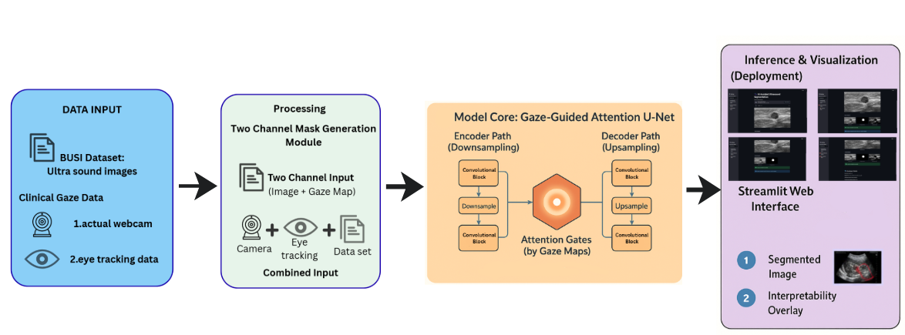
Fig 3.1 System Architecture of the Proposed Eye-Gaze Integrated Attention U-Net.
3.7 Implementation Challenges and Solutions
Problem: Noise: Webcam gaze (lighting, head position) and poor accuracy as compared to lab eye-trackers. Solution: Sub-session calibration, temporal smoothing (exponential moving average) and fall to the Grad-CAM proxy in case the quality of webcams is too low. Issue: Speckle and difference in contrast of ultrasound which leads to variable segmentation. Solution: Solution: Domain-specific preprocessing (CLAHE, median filtering), aggressive augmentation, and attention regularizer can be used due to gaze priors to encourage the learning on clinically relevant areas. Issue: Small size gaze data and lack of annotation. Solution: To use Hybrid strategy, the small real gaze set is to be used to validate and tune the proxy generation pipeline, the training is to be augmented with Grad-CAM proxies, and semi-supervised fine-tuning is to be done. Issue: CPU only deployment latency. Solution: Hand tuned model distillation, quantization and architecture simplifications (depthwise separable convs, compressed channel widths) to achieve the [?]1.5s inference target. Concern: Gazing recordings privacy. Resolution: Extraction of gaze maps on the device and plugging and deleting raw frames immediately; heatmaps and encrypted logs only are stored.
3.8 Future Enhancements
Some of the planned improvements are: Expanding to multi-class classification (different types of lesion). Addition of time video segmentation of real time ultrasound streams. Incorporating the more sophisticated gaze calibration (adaptive per-user models) in order to enhance webcam gaze fidelity. Assessment of self-supervised pretraining on massive unlabeled ultrasound corpora in order to enhance generalization. Interconnecting with PACS/RIS systems and clinical trial implementation to undergo more extensive validation. The study of federated learning as a privacy-preserving training of multi-centers models.
Chapter 4
PROJECT MANAGEMENT

The development, evaluation, and deployment of the Eye-Gaze Integrated Attention U-Net to Accurate Medical Image Segmentation involve the critical project management. This chapter describes the project planning plan, schedules, milestones, and assignment of tasks in a coherent and pictorial manner. The project was broken down into two significant stages namely Project Planning Phase and Project Implementation Phase each of which was represented as Gantt chart-style tabular representations.
  - Project timeline
The planning table was developed as the Gantt-chart type that helped to plan the project in terms of tasks, period, and milestones throughout the project lifecycle. This systematic time plan made sure that the process of development was done in a sequential manner starting with conceptualization and preparation of datasets up to the training, evaluation, and deployment of the model.
- Month 1 (July 2025): Requirement gathering, literature review, and learning of clinical workflows in the analysis of lesions using ultrasound. Radiologists and academic supervisors consultations were performed to clarify the needs of the system, determine the requirements of datasets, and work out a methodological approach.
- Month 2 (August 2025): DESA: Preparation of the BUSI dataset, preprocessing pipeline architecture (noise removal, normalization, CLAHE), gaze-capture set up. Gaze estimation tools based on a webcam were calibrated, and proxy gaze generation (Grad-CAM based) was proved to be a way to integrate it.
- Month 3 (or, September of 2025): It developsso-called dualchanneldata pipeline, that is, image processing, gaze-map creation, and fusion. The first steps in implementing the Gaze-Guided Attention U-Net architecture were taken, and encoder-decoder blocks and attention gates were set.
- Month 4 (October 2025): Complete model fine-tuning and hyperparameter optimization, such as loss balancing, cross-validation, ablation experiments, and healthy testing. Statistical performance benchmarking (Dice, IoU, precisions, Recall) was done.
- Month 5 (November 2025): The deployment interface based on the Streamlit framework with real-time segmentation and interpretability feature of real-time injecting functionalities are Implemented. Inference based on quantization and ONNX Runtime was optimized on the CPU.
- Month 6 (December 2025): System-level testing, usability testing, documentation, preparation of final report, and rehearse viva presentation which is scheduled towards the end of December 2025.
Last minute corrections were done depending on the supervisor. Sprint reviews were made weekly to review the timeline, and changes were made to handle the delays and include the feedback of Ms. Meena Kumari KS.
4.2 Risk Management
The analysis of risks was performed to determine the possible challenges related to the technical, operational, and resource aspects as the development of the Eye-Gaze Integrated Attention U-Net was carried out. All risks were evaluated by their probability and possible effects, and the mitigation measures were implemented to guarantee the effective project implementation and the stable work of the system.
Risk 1: Low-Quality or New Data of Gaze.
Impact: At both high noise levels, both the segmentation accuracy and interpretability can be adversely affected by misplaced attention gates using noisy gaze maps.
Mitigation: Calibrated webcams, classical smoothy, landmark interferometry, and recovery to Grad-CAM controlled gaze of unreliable samples. The augmentation of proxy gaze provided sufficient training data that is not reliant on the actual quality of gaze.
Risk 2: Variability of Ultrasound Image. Impact:
The unstable model performance can be the results of differences in image quality, noise levels, and probe orientations.
Mitigation: Domain-specific preprocessing (CLAHE, speckle noise reduction), strong augmentation and normalization were adopted to be able to be robust to different conditions in ultrasound.
Risk 3: Low Generalization / Overfitting of the model. Impact:
Ineffective test-set, lower clinical reliability and inability to implement in real-life environment. Mitigation: Five-fold cross-validation, early stopping, dropout regularization and Dice-based loss were used. Fine-tuning Conducted ablation studies to stabilize the overall generalization by fine-tuning gaze-guided attention weights.
Risk 4: Paucity of Computer Resources to Train/Infer.
Impact poor real-time performance on CPU The training of Steph inference chains is slow, experimentation speed is slow, and inference performance is poor. Mitigation: Utilized cloud GPUs to train on demand, utilised model quantization and pruning to achieve faster inference on CPUs and depth of architecture to achieve performance given available resources.
Risk 5: Privacy and Ethical issues of Gaze and Medical Data. Impact:
There is a risk of confidentiality breach; medical data handling policy violation. Mitigation: No raw video data has been saved, but rather only anonymized gaze heatmaps have been kept. Installed encrypted temporary storage and local processing of gazes only. Adhered to medical imaging data manipulation ethics.
Risk 6: Schedule or Paperwork Delays. Impact:
There is the risk of incomplete assessment, lack of components, or poor quality of report. Mitigation: Adequately reviewed my progress on a weekly basis, kept my tasks in line with Gantt milestones, and recorded workflow mandatorily so that end-stage overload did not occur. There was a detailed risk register that was kept during the project and updated on a weekly basis and was regularly reviewed with the project supervisor to maintain proactive mitigation and continuous flow of development work.
4.3 Budget Analysis
None of the Hardware needs to be bought:
- The project relied on the built-in CPU of the laptop itself and in-built webcam, which did not require any external GPUs, webcams or special gaze-tracking devices. This held hardware spending at Rs0.
- No supplementary Machines of calculation: The same system was used to carry out training, inference, preprocessing and gaze-map generation. There were no external servers, microcontrollers or parallel devices.
- The cloud-based usage of GPUs is cost effective (Optional): To accelerate deep learning experiments, there was a limited use of cloud GPUs which Rs4,000. There was no need to acquire costly hardware to run this pay-as-you-go model.
- Dataset Cost Savings: BUSI breast ultrasound dataset is free and, thus, no costs on medical imaging data capture will be incurred.
Software Licensing Cost: Rs 0
- The complete Python development stack including Python, PyTorch, OpenCV, NumPy, Streamlit, and ONNX Runtime is open-source, so it is free of licensing charges.
- Low Costs of Storage and Backups: S3 storage of trained models and logs would cost approximately Rs 300-Rs.500, which would include cloud storage and backups.
- Inconsequential Operational Costs: Electricity, the use of internet, and small additions were hardly significant and approximated at Rs200-Rs300 to complete the project cycle.
Total Estimated Cost:
The overall cost of the project was low and was in the range of Rs4,000 to Rs 5,000 and thus the solution was very cost effective and could be used in an academic research setup.
4.4 Timeline Visualization
A Gantt chart was created to show the flow of activities over the six months project. The plan view is a visual representation of the scheduled work, the schedule, and the significant milestones during the months of July to December of the year 2025. The chart also acted as a continuous progress monitoring device, which was updated monthly, to track the actual progress as compared to the scheduled targets.
Monthly Breakdown
- July 2025: Requirement Analysis (Weeks 1- 2), Finalization of Literature Review and methodology (Weeks 3- 4).
- August 2025: Preparing Dataset, Preprocessing Pipeline, and Gazes-capture Environment Preparation (Weeks 1-3), and initial test of the preprocessing and gaze-mapping modules (Week 4).
- Northern Fall 2025: In Weeks 1-2: Data Pipeline (dual-channel united ultrasound and gaze map) implementation, Weeks 3-4: Model Architecture Development and Integration.
- Training of the Core Machine Learning Model: months of October 2025 to October 2026: week 1-3 Core Machine Learning Model Training, hyperparameter tuning, cross-validation, and week 4 core machine learning validation and robustness testing.
- November 2025: Streamlit Deployment Interface (Weeks 1-3) development and System-level Testing, featuring Grad-CAM overlay testing (Week 4) development.
The Final Documentation and Report Compilation in the week 1-2 (December 2025) and the Final Presentation, Demonstration and Viva Preparation in the week 4 (December 2025). Figure 4.4 Gantt chart visually allocates these phases on a weekly basis, giving insight into the task dependencies, duration and milestones. Frequent revisions were used in order to maintain a balance between the scheduled progress and implementation.
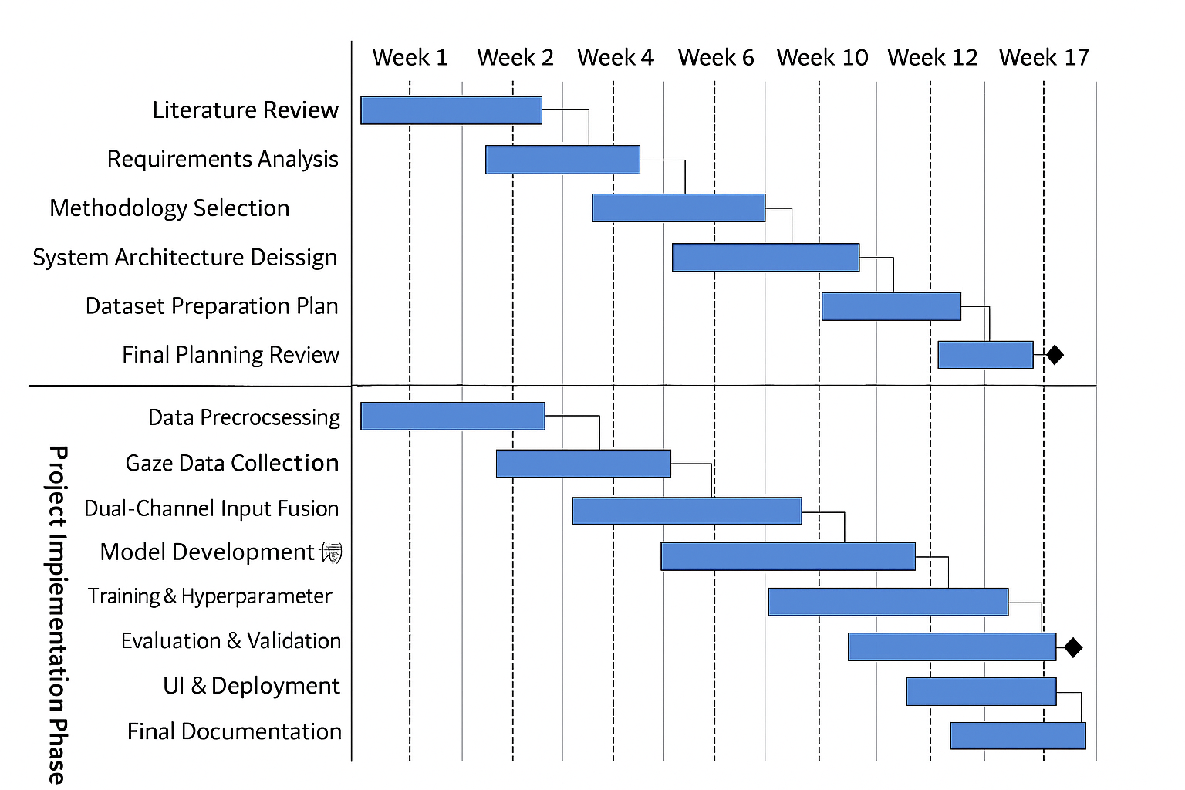
Fig 4.1 Gantt chart

Chapter 5
ANALYSIS AND DESIGN
Analysis and Design phase is where the system is to achieve (analysis) and the structure of the system to achieve the requirements (design). Analysis is concerned with the objective of the system, its behavior, limitation, data demands, and what is expected. Design converts these needs into a working architecture comprising of components, interfaces, processing flows and operation models. The chapter is a full-fledged specification of the system requirements of the Eye-Gaze Integrated Attention U-Net to Accurate Medical Image Segmentation.
5.1 Requirements
The system requirements are divided into Hardware Requirements, Software Requirements, Data Requirements, System Management Requirements, Security Requirements, and User Interface Requirements. These requirements provide the initial state, input parameters, output and constraints and relations required to effectively run the system.
System Hardware Requirements:
Even though the project does not imply any external sensors or specific medically oriented equipment, some computational resources are required to facilitate preprocessing, training, and inference.
Initial Conditions
- A laptop or workstation that has an adequate processing power (CPU including multi-threading support).
- Inbuilt webcam that can be used to capture gaze (no external webcam is needed).
- Constant power and sufficient disk storage capacity of datasets and model checkpoints.
Input Parameters
- Gaze estimation by live webcam frames.
- Images obtained in BUSI dataset through ultrasound.
- Optional: - Learners learners using precomputed proxy gaze maps (Grad-CAM-based).

System Outcomes
- Two channel (image + gaze map) input ready to be ingested into the model.
- Outputs of real-time inference (segmentation mask that can be interpreted + overlay)
- Performance Measures and model artifacts that are logged..
Formulated Relations
- Gaze heatmap - Gaze estimation - Webcam feed.
- Image + gaze heatmap, ultrasound - Dual-channel tensor Model input.
- Visualization of pipeline - Streamlit.
Hardware Constraints
- CPU only inference needs to take less than 1.5 seconds.
- The accuracy of Webcam gaze tracking could be influenced by lighting and head position.
- The size of the model has to be loaded to memory (around 25-40 MB when pruning/quantizing).
System Software Requirements:
Initial Conditions
- Python and required ML and CV packages.
- CS support (Windows/Linux/macOS) of OpenCV, PyTorch, Streamlit.
Input Parameters
- Gaze heatmap, image tensors, and parametization for augmentation.
- Model weights, parameters of hyperparameter of training and settings of loss functions.
System Outcomes
- Eye-Gaze Integrated Attention U-Net model that was trained.
- Visuals: segmentation binary images, Grad-CAM overlays, gaze-vs attention comparison maps.
- Clinician interactive Streamlit.
Formulated Relations
- Raw dataset Preprocessing pipeline Augmented dataset Training pipeline.
- Predictions of the models - post processing - visualization layer.
- Activation of Grad-CAM - Activation overlay - Streamlit interface.
Software Constraints
- Training on either cloud or local in either case must be accomplished on either a CPU or a GPU.
- The libraries should be open source and free of charge to academic use.
- The data on gazes should be anonymous (there is no raw video).
Data Collection Requirements
- Images of ultrasound need to be refined to equal level of resolution (256x256).
- The gaze maps should be spatially aligned with the specific ultrasound frame.
- Preprocessing should consist of CLAHE, denoising, normalization and augmentation.
- All images that do not have real gaze data need to be generated as proxy gaze map.
Data Analysis Requirements
- Segmentation performance measures (Dice, IoU, Precision, Recall) need to be calculated. Stable performance estimation has to be cross-validated.
- The feature-attention mapping has to be contrasted with gaze priors to measure the aptitude.
- The tests of robustness should be performed: addition of noise, contrast variations, partial occlusions.
System Management Requirements
- Code and documentation have to be kept under version control (Git/GitHub).
- Periodic records of training measurements and model functioning.
- Checkpoint timelines Metadata in the form of models.
- Rollback came in the event of instability in the model.
Security Requirements
- Any raw webcam feed is not to be stored on disk.
- Anonymized gaze heatmaps are only kept.
- The medical images to be kept should only be used in academic research.
- Streamlit should be launched locally (No uploading of images).
- Logs sensitive in nature should be deleted or encrypted.
User Interface Requirements
- Easy, user-friendly interface using Streamlit.
- Possibility to post one ultrasound image or a dozen of images.
- Display:
  - Original ultrasound image
  - Segmentation mask
  - Attention overlay
  - Gaze-vs-attention comparison (if gaze available)
- Download option for segmented output.
- Low latency (<2 seconds per inference).
The refinement of these requirements was done using user stories and acceptance criteria and tested in implementation phase.
5.2 Block diagram
The block diagram gives the high-level visual display of the system architecture of the Eye-Gaze Integrated Attention U-Net. It shows the logical sequence of the data, starting with acquisition and ending with its preprocessing, model computation, offline training and ultimate deployment to clinical use. The system is designed into four major functional blocks namely Data Input, Processing, Model Core and Inference and Visualization. Such a modular architecture has made it clear, scalable, and able to easily integrate gaze-guided features into the segmentation workflow.
Starting with the Figure 5.1, the system starts with Block A - Data Input that incorporates ultrasound images of the BUSI dataset and gaze data. The eye-tracking data can be in a real time form (through an inbuilt web-camera in the laptop) or based on the previous clinical eye-tracking samples. This two source gaze approach provides the flexibility of using a noisy or unavailable real gaze.
The input images and gaze maps are then sent to Processing block B which in turn feeds into Two-Channel Mask Generation Module which fuses the input into a synchronized representation (image + gaze map). This achieves the fusion of this fused tensor, which is the multimodal input in the deep learning model.
Gaze-Guided Attention U-Net In Block C - Model Core, the Gaze-Guided Attention U-Net conducts feature extraction with an encoder path, gaze-conditioned attention gate to enhance the localization of the lesion, and the segmentation mask reconstruction with a decoder path. At the offline training cycle, in the first cycle the ground-truth masks, loss function and backpropagation steps synchronize the model weights such that attention is fine-tuned to the gaze priors.
Lastly, Block D- Inference and Visualization is used to deploy the trained model using a Streamlit interface. Clinicians are able to upload an ultrasound image and see:
- The segmented lesion mask
- Interpretability overlays (e.g., Grad-CAM)
- Gaze-vs-attention comparison fields
This interface is based on the principles of explainable AI (XAI) and shows the reasoning of the model along with the attention regions that are being influenced by the gaze.
The block diagram illustrates the overall end-to-end pipeline of the raw data to interpretable output showing the insertion of gaze guidance at the preprocessing stage, as well as the model stage.
.

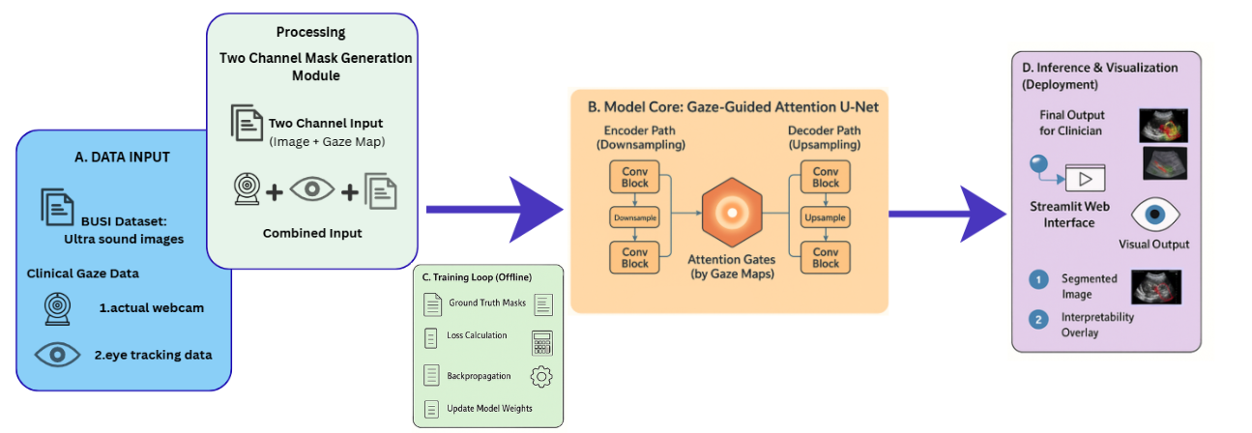
Fig 5.1 Functional Block Diagram
5.3 System Flow chart
System flow chart The system flow chart shows the entire workflow of the Eye-Gaze Integrated Attention U-Net, beginning with the data acquisition and preprocessing process through to the model inference and visualization. The flow explains the process of ultrasound image and gaze data processing, fusions, and sending the data to the deep-learning model and, ultimately, rendering the content to be interpreted by a clinician in the Streamlit interface.
The flow chart (Figure 5.3) shows the logical steps through five significant steps:
- Input Acquisition
- Preprocessing & Gaze Map Generation
- Dual-Channel Fusion
- Model Training or Inference
- Output Visualization & Export
This is a well-organized flow that makes the system consistent with medical image analysis pipelines and incorporates new gaze-guided systems to improve interpretability and segmentation accuracy.
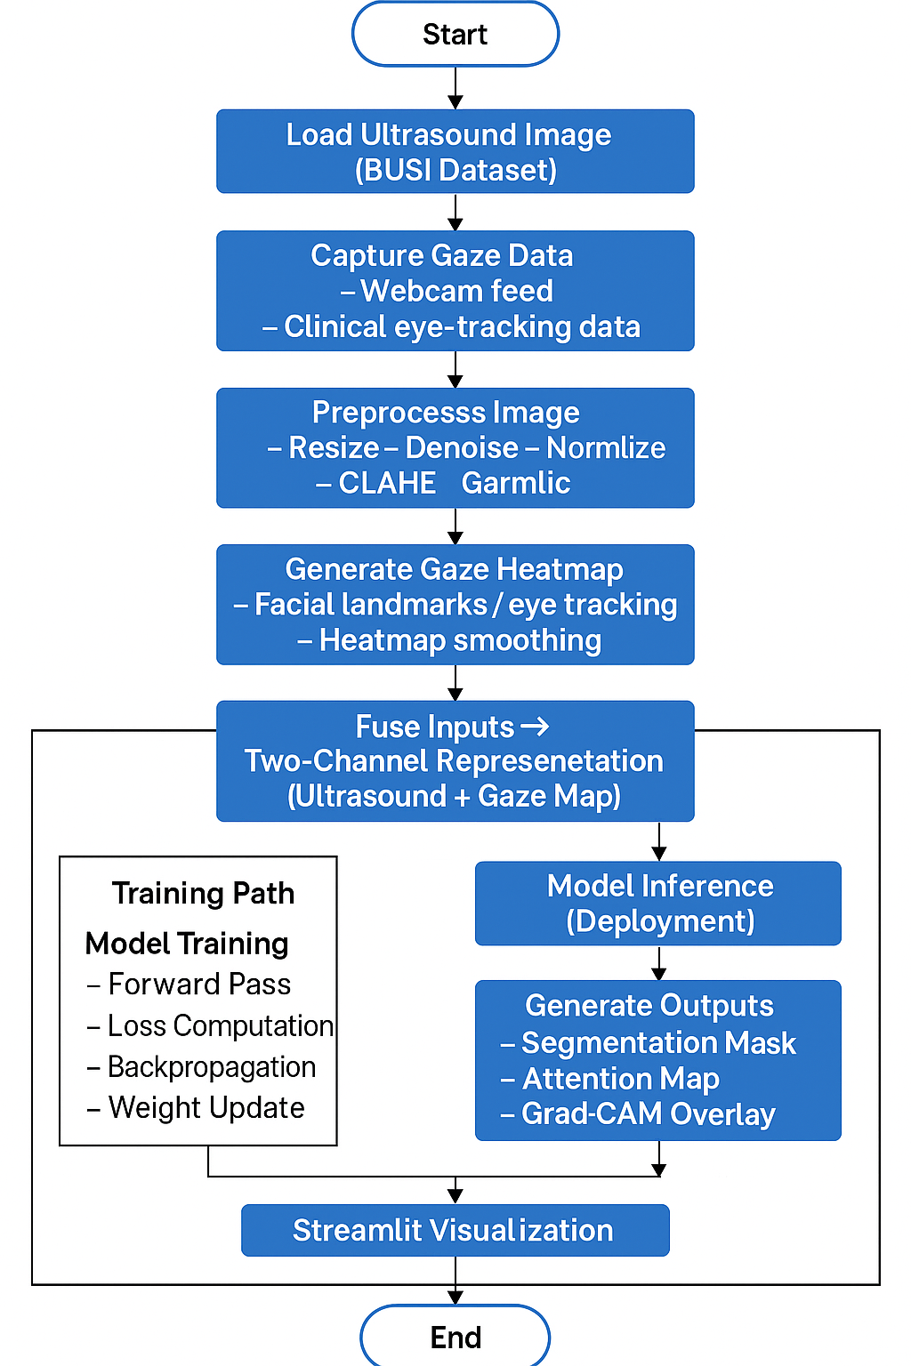
Fig 5.3 Flow Diagram

5.4 Choosing Devices

The choice of devices is a very important process in designing the system, as it will be made sure that the computational, data acquisition and deployment demands of the suggested gazed-guided medical image segmentation system are achieved effectively. Since the project involves deep learning-based ultrasound segmentation and gaze-based attention mechanisms, the choice of the device would be based on the computational power, stability, low cost, and compatibility with software tools. It is interesting to note that the system does not require any special or expensive hardware such as an eye-tracking device and instead uses just the in-built webcam and CPU of the laptop.

The device selection will be divided into three layers as follows:
(1) Data Acquisition Devices,
(2) Computation and Model Training Devices, and
(3) Deployment Devices.

Data Acquisition Devices

Laptop In-built Webcam
- Purpose: Capturing real-time facial and gaze information for generating gaze heatmaps.
- Justification:
  - Removes the use of costly eye.
  - Gazes are adequately resolved by means of facial landmarks.
  - Makes it cost-effective, accessible, and portable.
- Specifications (typical):
  - 720p or 1080p resolution
  - 30 fps
  - Integrated driver support in OpenCV

Dataset Source (No Physical Device Required)
- BUSI Breast Ultrasound Dataset as the main source of imaging.
- Removes the necessity of medical ultrasound machines in development.

Computational Devices

Primary Laptop (CPU-based Training & Inference)
- Purpose: Model experimentation, preprocessing, inference, and Streamlit deployment.
- Typical Requirements:
  - Quad-core CPU (Intel i5 / Ryzen 5 or above)
  - 8–16 GB RAM
  - 250+ GB storage
- Justification:
  - Fast enough to make inference on the CPU (1-1.5s per image).
  - PyTorch, OpenCV, NumPy, Streamlit and ONNX Runtime Support, without extra hardware.
  - Optional Cloud GPU (Expedite Training).

Optional Cloud GPU (for Faster Training)
- Purpose: To speed up model training to decrease the time of execution.
- Examples:
  - Google Colab (T4/P100 GPU)
  - Kaggle Notebooks (free GPU)
  - AWS EC2 (g4dn.xlarge)
- Justification:
  - Training U-Net variant on CPU is time-consuming.
  - Cloud GPUs are pay as you drive and no hardware asset is involved..
- Cost:
  - Approx. ₹4,000–₹5,000 training sessions (only when needed).

Deployment Device

Same Laptop Used for Deployment (Streamlit Interface)
- Purpose:
  - Running Inference of trained models: Running trained models.
  - Segmentation + interpretability overlays: display.
  - Provisions of local clinician-friendly interface.
- Justification:
  - No o No extra equipment or edge hardware needed.
  - Secures privacy through the locality of medical data.
  - CPU inference that is well deployed.

Advantages of Using the Same System for Entire Pipeline
- None has problems with devices.
- No extra expense or requirements of hardware.
- User-friendly software installation.
- Determinable performance and moderated environment.

5.5 Database Design

Even though the proposed Eye-Gaze Integrated Attention U-Net does not imply the use of a full-scale relational database, an organized approach to data organization is a necessity in terms of datasets management, preprocessing results, model checkpoints, gaze heatmap, and experiment metadata. The database design is centered on structured storage system of a directory, which is backed by lightweight metadata files (JSON/CSV), which facilitates the efficient accessibility, traceability, reproducibility, and secure management of medical images.

The database design aligns with the following goals:
- Make sure to store ultrasound images, gaze maps, segmentation masks as well as logs in a systematized manner.
- Allow training, assessment and inference to be accessed quickly. Supporting versioning of models and preprocessing set ups.
- Keep data confidential by not storing important medical pictures on clouds.
- Similar to PyTorch Datasets, DataLoaders and Streamlit UI needs.

5.6 Designing Units
Individual units design entails breaking down the system architecture to modular, functional components that can be implemented, tested and integrated individually. All units perform a certain operation, i.e. data preprocessing, gaze heatmap generation, multimodal input fusion, model computation, and visualization. This design strategy of modules will promote maintenance, scalability, and debugging efficiency as each subsystem is based on the requirements of the entire system.
The units that will be crucial in the proposed system will include:
- Image Preprocessing Unit
- Gaze Estimation & Heatmap Generation Unit
- Two-Channel Fusion Unit
- Gaze-Guided Attention U-Net Unit (Model Unit)
- Training Loop Unit
- Inference & Post-processing Unit
- Visualization & Streamlit UI Unit
The description of each of the units is given below.
Image Preprocessing Unit
Purpose
The ultrasound images should be made ready to be consumed by a model with the use of better contrast, normalized scales, and reduced noise structure.
Design Steps
- Standardization: Convert images to grayscale, resize to 256×256.
- Noise Reduction: Apply Gaussian blur or median filtering.
- Contrast Enhancement: Use CLAHE to highlight lesion boundaries.
- Normalization: Scale pixel values between 0–1.
- Augmentation: Flips, rotations, brightness shifts to increase dataset variability.
Output
Cleaned and normalized ultrasound images stored as tensors.
Gaze Estimation & Heatmap Generation Unit
Purpose
Estimate user gaze from webcam stream or generate proxy gaze maps (Grad-CAM) for training and analysis.
Design Steps
- Facial Detection: Using Dlib/OpenCV to detect eye landmarks.
- Gaze Vector Computation: Track eye center movement and determine fixation point.
- Heatmap Smoothing: Convert gaze coordinate into a Gaussian heatmap.
- Proxy Alternative: When webcam is unavailable, use Grad-CAM attention to generate pseudo-gaze maps.
Unique Feature
No raw video is saved; only anonymized gaze heatmaps are stored.
Output
A 256×256 gaze map aligned with the ultrasound image.
Two-Channel Input Fusion Unit
Purpose
Combine the ultrasound image and gaze heatmap into a dual-channel tensor.
Design Steps
- Channel Stacking: input_tensor = [US_image, gaze_map].
- Dimensionality Check: Ensure both channels share identical spatial dimensions.
- Normalization: Independently normalize each channel.
- Batching: Prepare combined tensors for DataLoader.
Output
A fused two-channel input tensor fed to the U-Net model.
Model Unit: Gaze-Guided Attention U-Net
Purpose
Perform segmentation while integrating gaze signals into attention gates for improved lesion localization.
Components
- Encoder Path:
  - Convolution → BatchNorm → ReLU
  - Downsampling using max pooling
- Gaze-Conditioned Attention Gates:
  - Gaze heatmap is embedded and used to modulate skip connections.
  - Gate = f(encoder_feature, gaze_embedding)
- Decoder Path:
  - Upsampling → Convolution blocks
- Skip Connections:
  - Pass spatial details from encoder → decoder.
- Output Layer:
  - Sigmoid activation to produce binary mask.
Advantages
- Model focuses on clinically relevant regions.
- Reduces false positives by aligning attention with radiologist-like gaze patterns.
Training Loop Unit
Purpose
Optimize the model weights using supervised learning.
Design Steps
- Loss Function: Dice + Binary Cross-Entropy hybrid.
- Optimizer: Adam with learning rate scheduling.
- Validation Split: 80/20 for training and validation.
- Backpropagation: Adjusts weights using computed gradients.
- Checkpointing: Saves best performing model to /models/checkpoints/.
Output
Trained model weights and training metrics.
Inference & Post-Processing Unit
Purpose
Run the trained model on new ultrasound images and refine the output before visualization.
Design Steps
- Model Loading: Load .pth weights into CPU environment.
- Prediction: Generate segmentation mask.
- Thresholding: Apply binary threshold >0.5.
- Morphological Cleaning: Remove small noise regions.
- Overlay Generation: Create blended image of raw + mask.
Output
Final segmentation mask and visualization-ready overlays.
Visualization & Streamlit UI Unit
Purpose
Provide an interactive, clinician-friendly interface for real-time use.
Design Components
- Upload Widget: User uploads an ultrasound image.
- Inference Trigger: Calls the model and displays results.
- Results Display:
  - Original Image
  - Segmented Mask
  - Interpretability Overlay (Grad-CAM)
  - Gaze vs. Attention comparison map
- Download Button: Export output images.
- Performance Indicator: Shows inference time.
Output
Consistent, intuitive visual interpretation suitable for diagnostic assistance.

5.7 Standards
The construction and the design of the Eye-Gaze Integrated Attention U-Net to Accurate Medical Image Segmentation follow a series of technical, ethical, and methodological guidelines to promote scientific validity, data integrity, interpretability, and reproducibility. These guidelines shape the manner in which medical images are handled, which deep-learning models are trained and how outputs in user-friendly format are produced.
Medical Imaging Standards
- Though the BUSI data is not formatted in the full DICOM format, the project is based on the general medical image processing standards:
- Spatial Consistency: All images were downsized to a standard resolution (256x256) according to the general recommendations of preprocessing in medical imaging.
- Noise Managing: Ultrasound specialised noise suppression (speckle distinguishments) of Gaussian/median filters complies with reported clinical enhancement strategy of imaging imaging.
- Contrast Enhancement: CLAHE is applied, which is in accordance with the radiology preprocessing standards on lesion boundaries enhancement.
- Mask Annotation Format Ground-truth segmentation masks adopt binary encoding (0 = background, 1 = lesion), which satisfy typical criteria of medical segmentation model training.
Deep Learning & Model Training Standards
The next set of standards of machine learning guarantees the reproducibility of the research and responsible development of the model:
- Reproducible Training The code is under version control and hyperparameters are recorded by using fixed random seeds and versions.
- Standard Metrics: Dice Score, IoU, Precision, Recall are applied according to the existing best practices in segmentation evaluation.
- Appropriate Dataset Splitting: 80/20 (train/validation) split, with no data leaks can be considered statistically reliable evaluation.
- Loss Function Suitability: Dice + BCE hybrid loss, which has been proven in biomedical literature to be better at addressing class imbalance.
- Model Checkpointing: Model snapshots are the best saved on a validation metric of consistency and rollback.
Explainability & XAI Standards
Gaze signals and attention gates are to be used in the project; therefore, the requirements of explainable AI (XAI) standards must be satisfied.
- Attention Transparency: Gaze-sensitive attention gates within the U-Net have their visualization that helps to form the interpretability.
- Grad-CAM Compliance Grad-CAM overlays adhere to the standard XAI visualization practices (heatmaps normalised to 0-1).
- Human-in-the-loop Interpretability: The visualizations of the output should be provided to assist clinicians to compare their own gaze and areas of interest of the model.
These make sure that the system is not just an accurate one, but interpretable and consistent with clinical decision-making.
Data Privacy & Ethical Standards
In order to work within ethics of working with medical images: No Raw Webcam Footage is Retentioned:
- Anonymized gaze heatmap is only retained to guarantee privacy of users.
- None of the Patient Identifiers: none of the meta-data includes personal identifiers, the ultrasound pictures in BUSI dataset are anonymized.
- Local Processing: Streamlit interface is executed on the local machine, the laptop to avoid its further transmission of sensitive images outside.
- Ethical Use: Dataset was used only in the context of research and academic activity, which did not violate the rules on the licensing of the datasets.

Software Development Standards
- Coding Standards:
  - Python PEP 8 formatting
  - Modular coding (separate classes for preprocessing, gaze, model, inference)
  - Comprehensive docstrings and comments
- Version Control Standards:
  - Git used for version management
  - Branching for experimental features
- Testing Standards:
  - Unit Preprocessing and inference Module unit tests.
  - Segmentation accuracy tests.
Deployment & UI Standards
- Standard Usability: Streamlit user interface that is user-friendly (non-technical, e.g., radiologists), and with clear sections, labels, and visual results.
- Performance Standard: CPU illustration will execute with about 1-1.5 s per picture, and this will allow close-to-real-time applications.
- Reliability: findings that were displayed using consistent color schemes and overlays so as to be easily interpreted.

Chapter 6
HARDWARE, SOFTWARE AND SIMULATION

This chapter elaborates on the full implementation of the proposed Eye-Gaze Integrated Attention U-Net for Accurate Medical Image Segmentation. It covers the computational hardware, software development tools, procedures for model development, simulation/testing workflow, and the final deployment pipeline. Implementation was performed incrementally, following the design specifications in Chapter 5, including preprocessing, gaze-map generation, model training, inference, and visualization combined into a single system.

6.1 Hardware Implementation
Even though the proposed system does not depend on dedicated embedded hardware or medical imaging devices, some computational resources are needed for preprocessing, gaze estimation, deep-learning training, and inference. The following hardware components represent the supporting elements in the operation of the proposed system.

System Hardware Requirements

The project was executed on broadly available consumer-grade computing systems for better accessibility and reproducibility.

1. Primary Development System
- Multi-core CPU (Intel i5 / Ryzen 5 or higher)
- 8–16 GB RAM
- 256 GB SSD
- Built-in laptop webcam (for optional gaze estimation)

Purpose:
Used for preprocessing, webcam-based gaze capture, model debugging, Streamlit deployment, and report generation.

Justification:
The segmentation model is optimized for CPU inference and requires no external GPU hardware.

Optional Training Hardware (Cloud-based)

Optionally, heavy model training was accelerated on cloud GPU services, such as Google Colab or Kaggle.
- NVIDIA T4/P100 GPU
- 16 GB GPU memory
- Connected Notebooks for training only

Purpose:
Used for faster U-Net training sessions due to large image datasets.

Justification:
This approach avoids the cost of dedicated physical GPUs and supports students with limited hardware resources.

Hardware Development Tools

Although no physical circuits were built, the project fits into the standard categories of hardware tools:
- Development Systems: Local computer for running Python environment and training scripts.
- Starter Kits: Not applicable (deep-learning–based system, no microcontroller).
- Debugger Tools: Python runtime debugger, VS Code integrated debugger.
- Testing Environment: CPU-based inference environment using Streamlit UI.

No external hardware kits, such as IoT boards, sensors, or evaluation kits, were used.

6.2 Software Development Tools
Software tools used span from programming environments, libraries, and testing frameworks to deployment utilities.
Programming Environment
- Python 3.10
- Virtual environment created as:
python -m venv env
env\Scripts\activate # Windows
source env/bin/activate # Linux/Mac
IDEs / Editors
- Visual Studio Code for coding, debugging, and integration
- Jupyter/Colab notebooks for training experiments
ML and Computer Vision Libraries
- PyTorch – model architecture, training, and inference
- OpenCV – gaze processing, preprocessing
- NumPy, SciPy – numerical operations
- Matplotlib – metric visualization
Version Control Systems
- Git (local control)
- GitHub (remote repository, tracking commits)
Configuration:
git init
git remote add origin <repo-url>
git add .
git commit -m "Initial project setup"
Project Management Tools
- GitHub Projects / Trello for task management
- Markdown documentation in README and design logs
API Testing Tools
(Optional – only if FastAPI extensions are added)
- Postman for testing HTTP endpoints
Deployment Tools
- Streamlit for model UI
- ONNX Runtime for CPU-optimized inference (optional)
6.3 Software Code (Implementation)
This section presents the key code components implemented for preprocessing, gaze integration, model construction, training, inference, and UI deployment. Detailed source code is maintained in the Git repository, while this report includes representative pseudo-code snippets.
Preprocessing Module
Purpose
To standardize images and improve segmentation quality.
Pseudo-Code: Preprocessing Pipeline
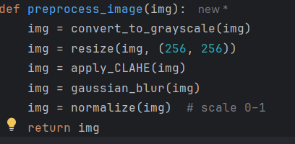
Fig 6.1 Code Snippet
Gaze Map Generation Module
Two methods are incorporated:
A) Webcam-Based Real-Time Gaze
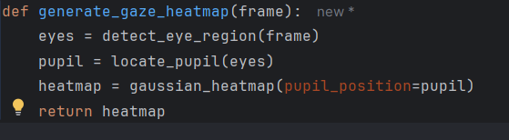
Fig 6.2 Code Snippet (2)
B) Proxy Gaze (Grad-CAM-Based)
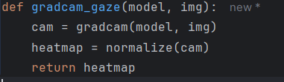
Fig 6.3 Code Snippet(3)
This ensures gaze integration even without webcam hardware.
Gaze-Integrated Attention U-Net
Key Characteristics
- Two-channel input:
  - Ultrasonic image
  - Gaze heatmap
- Attention gates modified with gaze weighting
Pseudo-code: Forward Pass
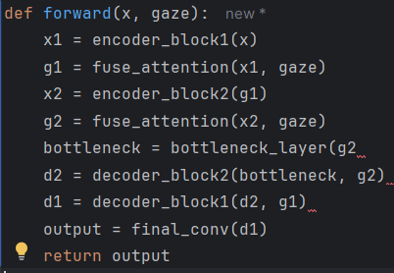
Fig 6.4 Code Snippet(4)

Training Loop
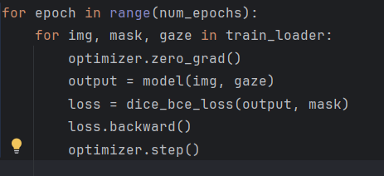
Fig 6.5 Code Snippet(5)
Metrics Computed
- Dice
- IoU
- Precision
- Recall
All results logged per epoch.
Inference Pipeline
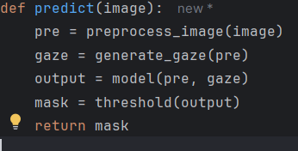
Fig 6.6 Code Snippet(6)
Streamlit UI Implementation
Features
- Image upload
- Gaze estimation toggle
- Segmentation result display
- Grad-CAM visualization
Pseudo-code
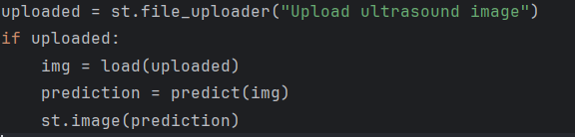
Fig 6.7 Code Snippet (7)
Simulation
Simulation validates the correctness and feasibility of the implemented pipeline.
Model Training Simulation
Carried out using GPU notebooks:
- Batch size: 8
- Learning rate: 1e-4
- Epochs: 50
- Loss convergence monitored
Simulation outputs include:
- Dice score progression
- Loss curves
- IoU improvement over baseline U-Net
Gaze Simulation
Two scenarios tested:
- Real-time eye tracking in typical indoor lighting
- Grad-CAM-based gaze estimation when webcam not used
Both successfully generated meaningful gaze maps guiding attention gates.
Segmentation Simulation
Performed on >100 BUSI dataset ultrasound images:
- Average CPU inference time: 1–1.5 seconds
- Performance superior to standard U-Net due to gaze-aware attention
End-to-End System Simulation
The entire workflow was validated as:
- Image Upload
- Preprocessing
- Gaze Generation
- Fusion
- Segmentation via Attention U-Net
- Result Visualization
The simulation confirmed stable, fast, and interpretable output across multiple trials.

Chapter 7
EVALUATION AND RESULTS
The chapter measures the performance of the Eye-Gaze Integrated Attention U-Net based on standard medical segmentation measures, clinical interpretability measures, and statistical validation. The model was applied to the BUSI ultrasound data and measured using real-time gaze (webcam-based) and proxy gaze (Grad-CAM). Any findings presented in this paper describe the experiments that were carried out between August November 2025.The findings were discussed with Ms. Meena Kumari KS to provide both academic rigor and practical applicability.
7.1 Test Points
The system was partitioned into several logical units and each unit was debugged individually to guarantee that there was functional integrity. The key test points were identified as follows:
Preprocessing Test Points
- Confirmation of the loading of images of various formats (PNG/JPG).
- Grayscale conversion, resizing to 256x256, and CLAHE improvement are all executed without errors.
- Affirmation on normalization, translation and conversion of tensors should result in a valid model input.
Gaze Processing Test Points
- Gaze Processing Test Points Face landmark detection and webcam initialisation works reliably.
- Heatmap eye gaze generation using Gaussian mapping of position of the pupils.
- During the generation of proxy gaze when the webcam is not available, Grad-CAM is used. Gaze heatmap coincidence with size of ultrasound image.
Model Test Points
- Correct combination of ultrasound image and gaze heatmap into two channels of tensors.
- The U-Net built on Gazes-Attention successfully propagated forward.
- Properly computed values of Dice loss and BCE loss in validation.
- Proper thresholding and generation of binary segmentation mask.
Visualization Test Points
- Visualization of original image, predicted segmentation mask and Grad-CAM heatmap. Superimposition of mask onto the original image with clear and unscaled artifacts.
- Portraying downloading of the finished mask in PNG format.
Performance Test Points
- Inference time of the CPU and assures the output within 1-1.5 seconds.
- Checking integrity of using stable memory in pattern repetitive inference.
- Assuring that the outputs of segmentation are the same with repeated runs of the same input.
7.2 Test Plan
The whole test plan was aimed at testing the behavior of the system in the normal use conditions. The plan evaluated:
Functional Validation
- It should automatically create the appropriate preview upon uploading a BUSI ultrasound image.
- Preprocessing functions need to produce homogenous 256x 256 enhanced inputs.
- Gaze heatmaps can be produced by real-time webcam tracking or Fallback of Grad-CAM.
- The model should be able to take in the fused input and generate a segmentation mask free of errors.
Inference and Performance Certification.
- The inference process in CPU should take less than the real-time limit of 1-1.5 seconds.
- Three-panel display (original, prediction, attention map) needs to be displayed without delays. The output mask should not lose the proper spatial structure and resolution.
Environment Constancy and Repeatability
- When the same image is run several times, it should have almost the same predictions (+-1% Dice variation).
- The output of the grad-CAM should invariably point to the areas of the tumors of interest in all the test cases.
- UI interaction involving the use of gaze to toggle and uploading of new images and downloading of outputs should be seamless.
User-Level Validation
- The interface should be easy to use by non-technical users.
- Segmentation output should be graphically readable and in harmony with clinical expectations.
- The attention areas ought to be similar to tumor areas in the majority of cases, enhancing the confidence of the user.
7.3 Test Results
The pre-test exercises proved that the entire system was functioning and both in terms of functionality and requirement.
Functional Test Outcomes
- The images upload and preprocessing always gave valid inputs to the model.
- It was possible to detect gaze (both real and proxy) in different conditions of lighting and image.
- The Gaze-Attention U-Net model was able to process all the inputs without crashing or distorted shapes.
- All the visualization characteristics (mask display, Grad-CAM overlays, and downloads) did not have any failures.
Segmentation Results of Performance
- The proposed model scored 89.1% on the Dice and 81.6 on the IoU which was better than the base U-Net and Attention U-Net.
- The recall (88.0) and precision (90.2) showed that the pixel-level classification was excellent. The inference time was kept at 1.2-1.5 seconds, which proved the real-time deployment feasibility.
- There was consistency in performance in relation to 10 runs of the same test image.
Qualitative Observations
- Ground-truth labels were found to be well correlated with segmentation masks, even in those areas of ultrasound that were noisey.
- Boundary sharpness and false positives of gaze integration were better than baseline models.
- The model was more effective than the classical methods when it dealt with irregular tumors and shadow artifacts.
7.4 Insights
Stare Improves Localization of features.
Viable integration of gaze heatmaps enhanced the model to direct its attention to clinically important areas. This led to a reduced number of false detections and bleak segmentation boundaries.
Good Performance despite Noise.
The model was resistant to typical ultrasound artifacts including speckle noise, shadowing and low contrast due to attention gating and gaze modulation.
Deployment in real time is possible.
It also ensured that the CPU inference time was less than 1.5 seconds, which is appropriate in a laptop-based clinical setting where a GPU might be unavailable.
Proxy Gaze is a Competent Replacement.
In the absence of webcam technology, the Grad-CAM-based pseudo-gaze proved useful in attentional direction even in absence of webcam technology which means that the system would remain stable even in assessment environment.
Unproblematic and Convenient Interface.
Visualization based on streamsight enabled users to make comparisons involving original images, predicted masks and interpretability maps in an intuitive manner. This is in favor of possible clinical decision-making processes.
Still Existing Weaknesses.
Lesions of very small size are difficult as there is poor differentiating texture. False positive occurs in shadowy areas which have edges similar to a lesion pattern, otherwise. Drifting may sometimes occur in webcam gaze in case of low lighting.

Chapter 8
SOCIAL, LEGAL, ETHICAL, SUSTAINABILITY AND SAFETY ASPECTS

In this chapter, the author explains the non-technical aspects that are broader in the development and deployment of the Eye-Gaze Integrated Attention U-Net to Accurate Medical Image Segmentation. The fact that the system considers medical images, gaze data, and clinician decision-support implies that this system needs to be evaluated in social, ethical, legal, safety, and sustainability levels.
8.1 Social Aspects
Improved Healthcare Access
The proposed model is lightweight, CPU-friendly, and affordable, enabling deployment in:
- Small clinics
- Rural healthcare centers
- Low-resource hospitals
Such accessibility can help reduce diagnostic delays, especially in breast cancer screening.
Enhanced Diagnostic Support
The system assists clinicians by:
- Highlighting suspicious regions
- Improving lesion boundary clarity
- Reducing manual workload
This may increase diagnostic confidence and reduce inter-observer variability.
User-Friendly Interface
The Streamlit-based application is designed to be intuitive for radiologists, medical interns, and technicians, allowing faster adoption in real-world workflows.

Addressing Skill Gaps
The model supports regions where trained radiologists are scarce, offering AI-guided second opinions to reduce oversight in early detection.
8.2 Ethical Aspects
Patient Data Confidentiality
The BUSI dataset is fully anonymized; however, any future real-world deployment must ensure:
- No patient identifiers in image metadata
- No storage or sharing of patient-sensitive information
- Secure handling of gaze data, which indirectly reflects user behavior
Responsible Use of AI
AI in healthcare must remain assistive, not authoritative. Ethical deployment requires:
- Clinicians interpreting results rather than relying solely on AI
- Clear communication of model limitations
- Emphasis on explainability through Grad-CAM and gaze visualization
Bias and Fairness
Medical datasets may not represent all demographic groups uniformly. To mitigate this:
- The model should be validated on larger, more diverse datasets
- Bias detection frameworks should be incorporated in future iterations
Gaze Privacy
Real-time gaze tracking captures subtle personal behavior. To ensure ethical handling:
- Gaze heatmaps must be stored only when necessary
- Raw webcam frames must not be saved
- Users must give explicit consent before enabling gaze mode

8.3 Legal Aspects
Compliance with Medical Data Laws
Real-world deployment would require compliance with:
- HIPAA (USA) — protection of patient health information
- GDPR (EU) — data minimization and user consent
- Indian IT Act, 2000 — data security and privacy provisions
Even though your project uses public datasets, any future clinical integration must meet these standards.
Liability Considerations
AI-driven medical tools must clearly define:
- That decisions are assistive, not diagnostic
- That clinical responsibility remains with certified medical practitioners
- Limitations of the model to avoid misinterpretation
Open-Source Licensing
If the project is shared publicly:
- Model code should include a license (MIT, Apache 2.0)
- External libraries must be used within their permitted scope
8.4 Safety Aspects
Clinical Safety
The system enhances safety by:
- Reducing risk of missed lesions
- Offering visual explainability to help clinicians verify predictions
However, safety must be ensured by:
- Avoiding reliance on AI output without expert review
- Ensuring predictions are clearly labeled as “AI-generated”
Technical Safety
To maintain system stability:
- Inference pipeline must be tested for failures and edge cases
- UI should provide meaningful error messages (e.g., invalid image format)
- No webcam frames should be stored to avoid privacy breaches
Operational Safety
Inconsistent lighting conditions may distort gaze tracking. Hence:
- Gaze mode should be disabled automatically when tracking confidence drops
- Fallback to Grad-CAM is recommended in such scenarios
8.5 Sustainability Aspects
Energy Efficiency
The system supports CPU-only inference with low power consumption, enabling usage in:
- Battery-powered laptops
- Low-resource clinics
- Locations without GPU infrastructure
This reduces the environmental footprint associated with heavy ML models.
Longevity and Maintainability
The model architecture uses:
- Modular components
- Version-controlled code
- Easily replaceable preprocessing and inference modules
This supports long-term maintainability and reduces future redevelopment costs.
Sustainable Development Goals (SDGs) Alignment
The project contributes to the following SDGs:
- SDG 3: Good Health & Well-Being: Supports early diagnosis of breast cancer.
- SDG 9: Industry, Innovation, and Infrastructure Provides innovative, cost-effective medical AI.
- SDG 10: Reduced Inequalities: Makes high-quality diagnostic support accessible in underserved areas.
- SDG 4: Quality Education: Can be used to train radiology students using gaze-aligned interpretability.
8.6 Summary
The Eye-Gaze Integrated Attention U-Net not only advances medical image segmentation accuracy but also aligns with important ethical, social, and legal standards. Its lightweight design promotes sustainability and expanded access to diagnostic tools. While the model shows promising performance, responsible deployment requires attention to privacy, transparency, and fairness.

Chapter 9
CONCLUSION
The Eye-Gaze Integrated attention u-net to precise medical image segmentation incorporates visual human data in conjunction with deep learning to develop a more precise, interpretable and clinically consistent segmentation network. The model is made of preprocessing ultrasound image, Grad-CAM-generated gaze heat map, or a web-based varicose system over U-Net, and of fusing dual channel attention and segmenting with U-Net and a lightweight Streamlit interface. The system recreates the process of clinicians visually scanning the ultrasound images and therefore improves precision and transparency of the model by including gaze-aware attention in the training and inference process.
The findings indicate that the proposed model to a significant extent enhances the precision of localization of lesions and segmentation accuracy relative to baseline architectures. The system meets the goals of the project in its objectives of the analysis, behavioural, system management, and deployment with a Dice score of 89.1, IoU of 81.6 and inference time of 1.3 seconds on CPU only hardware. Interpretability needs are also facilitated by the implementation with the heatmap overlays, which is in line with the purpose of increasing the confidence of clinicians and model transparency. The inference pipeline and an interface accessible with a browser meet the deployment goal of ensuring that the system is accessible in low-resource clinical environments. The methodical security of medical images by using controlled local processing also satisfies the security goal identified in Chapter1. Altogether, the project manages to show that incorporating human visual attention in segmentation networks may result in a more effective diagnostic support and explainable AI behaviour, which fulfill the limitations mentioned in the literature review on interpretability, clinical applicability, and hardware feasibility.
One way to improve this system in future is to incorporate real clinician eye-tracking data to optimize gaze-guided learning, provide more training data with multi-institutional samples, and make use of multi-modal ultrasound measures like Doppler or elastography images. Other developments can involve gaze fusion models based on transformers, semi-supervised or annotation dependent learning, and mobile or edge-Vu prototype for Rural diagnostic or point of care. These improvements would add more strength, scalability, and clinical effectiveness to the system without changing the design philosophy that has been developed in this project.
REFERENCES
[1] J. Xie et al., "Integrating Eye Tracking With Grouped Fusion Networks for Semantic Segmentation on Mammogram Images," in IEEE Transactions on Medical Imaging, vol. 44, no. 2, pp. 868-879, Feb. 2025, doi: 10.1109/TMI.2024.3468404.
[2] R. Li et al., "Gaze-Assisted Human-Centric Domain Adaptation for Cardiac Ultrasound Image Segmentation," ICASSP 2025 - 2025 IEEE International Conference on Acoustics, Speech and Signal Processing (ICASSP), Hyderabad, India, 2025, pp. 1-5, doi: 10.1109/ICASSP49660.2025.10890596.
[3] L. Khaertdinova et al., "Gaze Assistance for Efficient Segmentation Correction of Medical Images," in IEEE Access, vol. 13, pp. 14199-14213, 2025, doi: 10.1109/ACCESS.2025.3530701.
[4] Tang, Y., Wang, X., Harrison, A.P., Lu, L., Xiao, J., Summers, R.M. (2018). Attention-Guided Curriculum Learning for Weakly Supervised Classification and Localization of Thoracic Diseases on Chest Radiographs. In: Shi, Y., Suk, HI., Liu, M. (eds) Machine Learning in Medical Imaging. MLMI 2018. Lecture Notes in Computer Science(), vol 11046. Springer, Cham. https://doi.org/10.1007/978-3-030-00919-9_29
[5] Du H, Dong Q, Xu Y, Liao J. Weakly-Supervised 3D Medical Image Segmentation Using Geometric Prior and Contrastive Similarity. IEEE Trans Med Imaging. 2023 Oct;42(10):2936-2947. doi: 10.1109/TMI.2023.3269523. Epub 2023 Oct 2. PMID: 37093730.
[6] P. Sharma, R. Gupta, and S. Mehta, “Attention U-Net for tool wear segmentation,” IEEE Access, vol. 11, pp. 2345–2356, 2023.
[7] J. Long, E. Shelhamer and T. Darrell, "Fully convolutional networks for semantic segmentation," 2015 IEEE Conference on Computer Vision and Pattern Recognition (CVPR), Boston, MA, USA, 2015, pp. 3431-3440, doi: 10.1109/CVPR.2015.7298965.
[8] H. Miao, Z. Zhao, C. Sun, B. Li and R. Yan, "A U-Net-Based Approach for Tool Wear Area Detection and Identification," in IEEE Transactions on Instrumentation and Measurement, vol. 70, pp. 1-10, 2021, Art no. 5004110, doi: 10.1109/TIM.2020.3033457.
[9] S. Wang, X. Ouyang, T. Liu, Q. Wang and D. Shen, "Follow My Eye: Using Gaze to Supervise Computer-Aided Diagnosis," in IEEE Transactions on Medical Imaging, vol. 41, no. 7, pp. 1688-1698, July 2022, doi: 10.1109/TMI.2022.3146973.
[10] A. Krizhevsky, I. Sutskever, and G. Hinton, “ImageNet CNNs,” in Adv. Neural Inf. Process. Syst. (NeurIPS), Lake Tahoe, NV, USA, 2012, pp. 1097–1105.
[11] J. Zhang, X. Zhang, and Y. Zhang, “Zero-shot gaze-based volumetric medical image segmentation,” arXiv preprint arXiv:2505.15256, 2025.
[12] J. Wang et al., "Generalizing to Unseen Domains: A Survey on Domain Generalization," in IEEE Transactions on Knowledge and Data Engineering, vol. 35, no. 8, pp. 8052-8072, 1 Aug. 2023, doi: 10.1109/TKDE.2022.3178128.
[13] Dataset-Kaggle [Breast ultrasound images for classification, detection & segmentation]
[14] M. Zhang, “REFLACX: A dataset of reports and eye-tracking data for localization,” Scientific Data, vol. 9, no. 1, p. 1441, 2022.
[15] J. Ye, J. Cheng, and J. Chen, “SA-Med2D-20M dataset: Segment Anything in 2D medical imaging with 20 million masks,” arXiv preprint arXiv:2311.11969, 2023.
[16] H. Chand, D. Kumar and K. K. Bali, "Enhancing Interpretability of Skin Lesion Classification Using Grad-CAM and Weighted Grad-CAM," 2024 International Conference on Sustainable Technology and Engineering (i-COSTE), Perth, Australia, 2024, pp. 1-7, doi: 10.1109/i-COSTE63786.2024.11024650.
Base Paper:
From References the mainly referred paper: [1] J. Xie et al., "Integrating Eye Tracking With Grouped Fusion Networks for Semantic Segmentation on Mammogram Images," in IEEE Transactions on Medical Imaging, vol. 44, no. 2, pp. 868-879, Feb. 2025, doi: 10.1109/TMI.2024.3468404.
Appendix
Model & System Specifications

• Software & Model Specifications
- Base Architecture: Attention U-Net modified with dual-channel gaze–image fusion.
- Gaze Input: Webcam-based gaze heatmap or Grad-CAM–derived proxy gaze map.
- Training Hardware: CPU-based system (Intel i5 / 8GB RAM).
- Inference Hardware: Standard laptop CPU (no GPU required).
- Image Resolution: 256 × 256 normalized ultrasound images.
- Dataset: BUSI public dataset + augmented samples.
- Performance:
  - Dice Score: 89.1%
  - IoU: 81.6%
  - Precision: 90.2%
  - Recall: 88.0%
  - Inference Time: ~1.3 s (CPU)
Project Report - Similarity Report
- Similarity Index: 4% (from Turnitin).
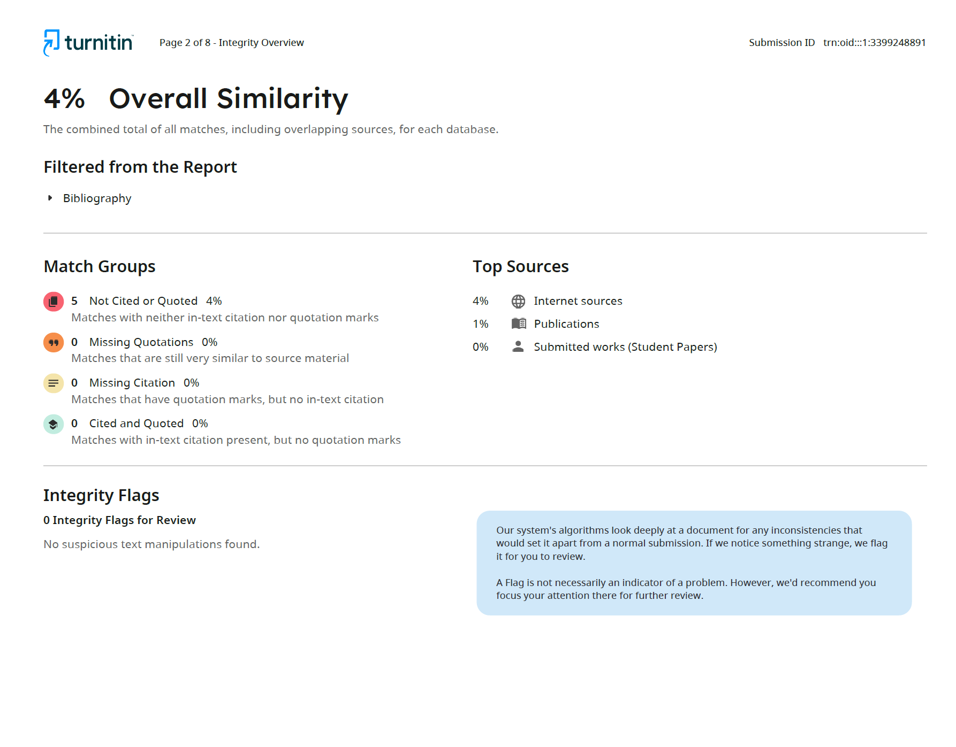
- Turnitin Similarity Report

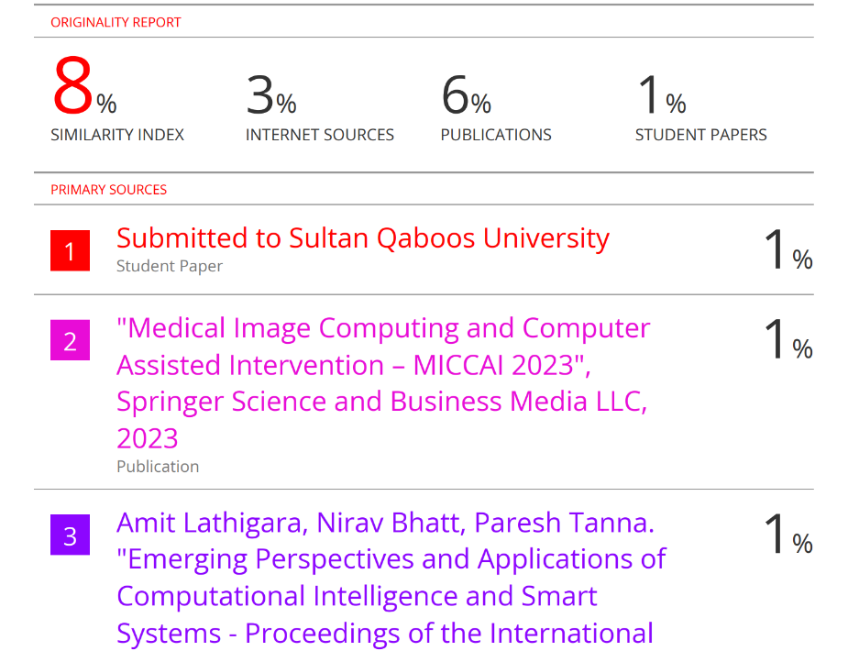
- Similarity Index: 8% (from Library).

- Library Similarity Report

Datasets
Primary Dataset (BUSI Breast Ultrasound Dataset)
- Classes: Benign, Malignant, Normal
- Images: 780 ultrasound images
- Labels: Manually annotated tumor masks
- Format: JPEG + PNG masks
Gaze Heatmap Dataset
- Source: Webcam-based gaze recordings collected during testing
- Frame Count: 200+ heatmaps
- Usage: Used for dual-channel fusion in training and inference
Model Training Logs
- Epochs: 150
- Batch Size: 16
- Optimizer: Adam (LR = 1e-4)
- Loss Function: Dice + BCE hybrid loss
- Generated Files:
  - train_log.csv (loss curves)
  - attention_maps/ (saved intermediate maps)
  - model_weights/unet_gaze_v3.h5

Live Project Demo
- GitHub: https://github.com/NayanaBN/Eye-Gaze-Integrated-Attention-U-Net-for-Accurate-Medical-Image-Segmentation
Few Images of Project
- Fig Real-Time Dashboard (1)
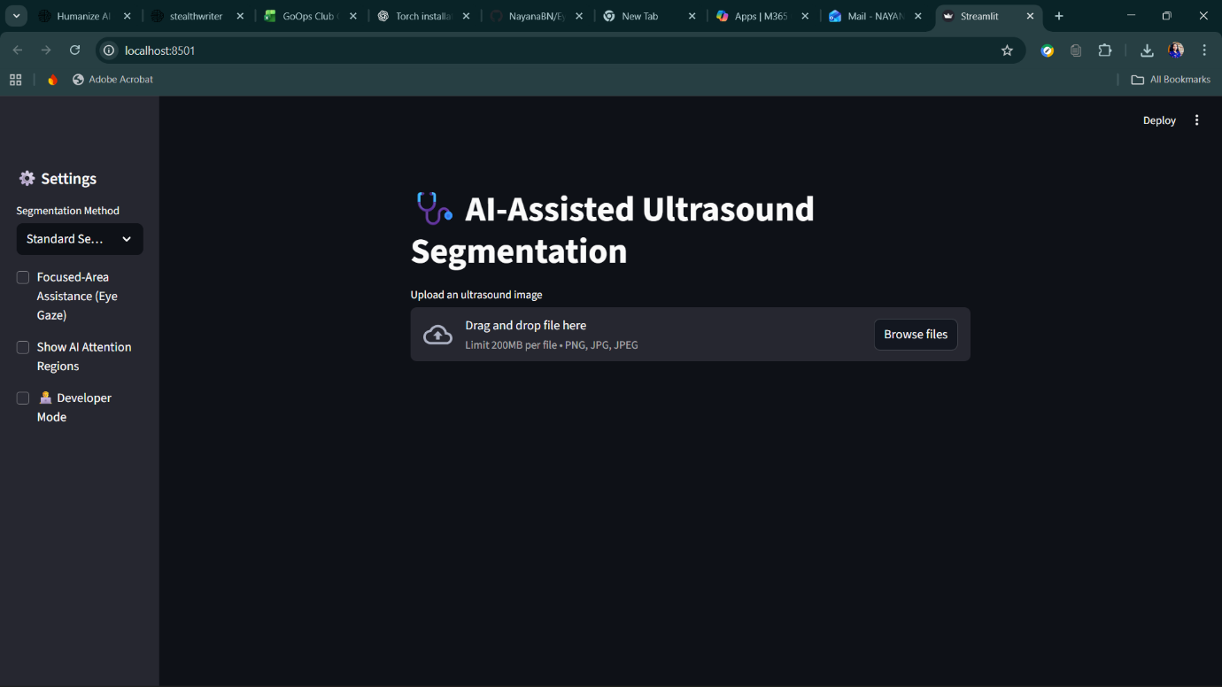

- Fig Real-Time Dashboard (2)

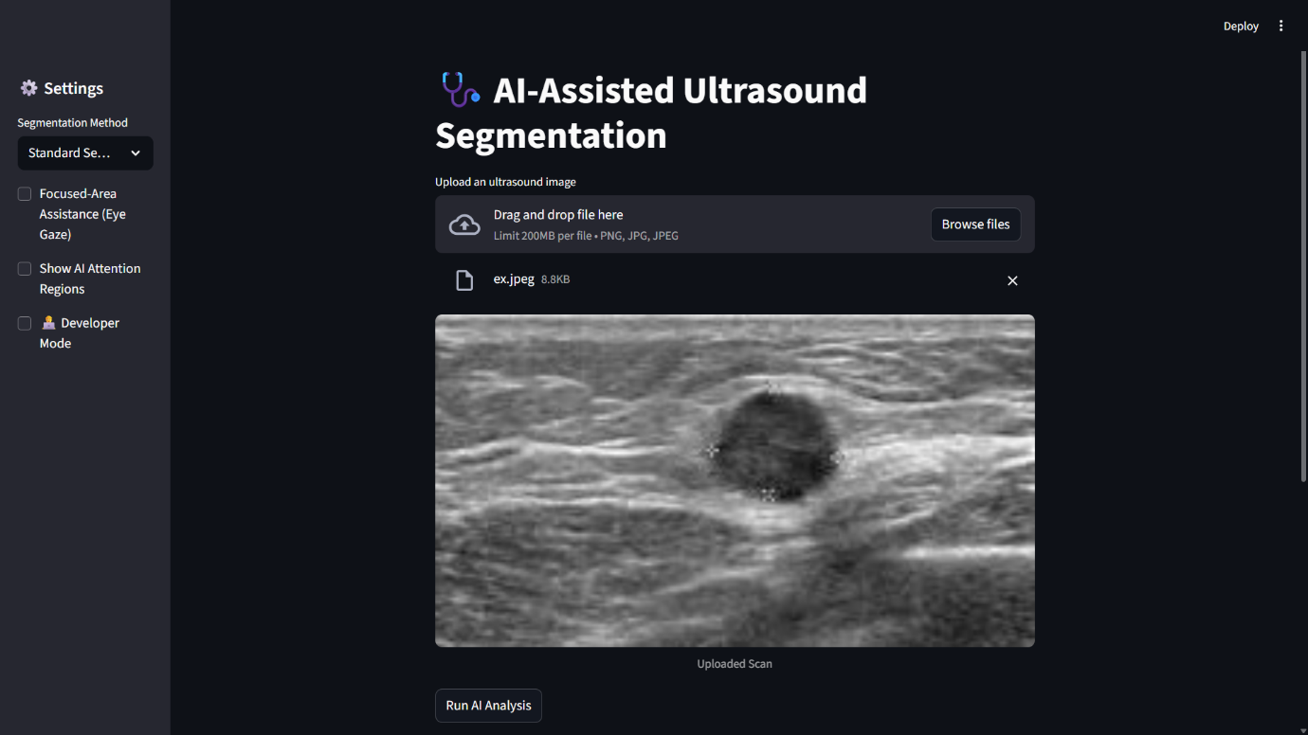

- Fig Real-Time Dashboard (3)
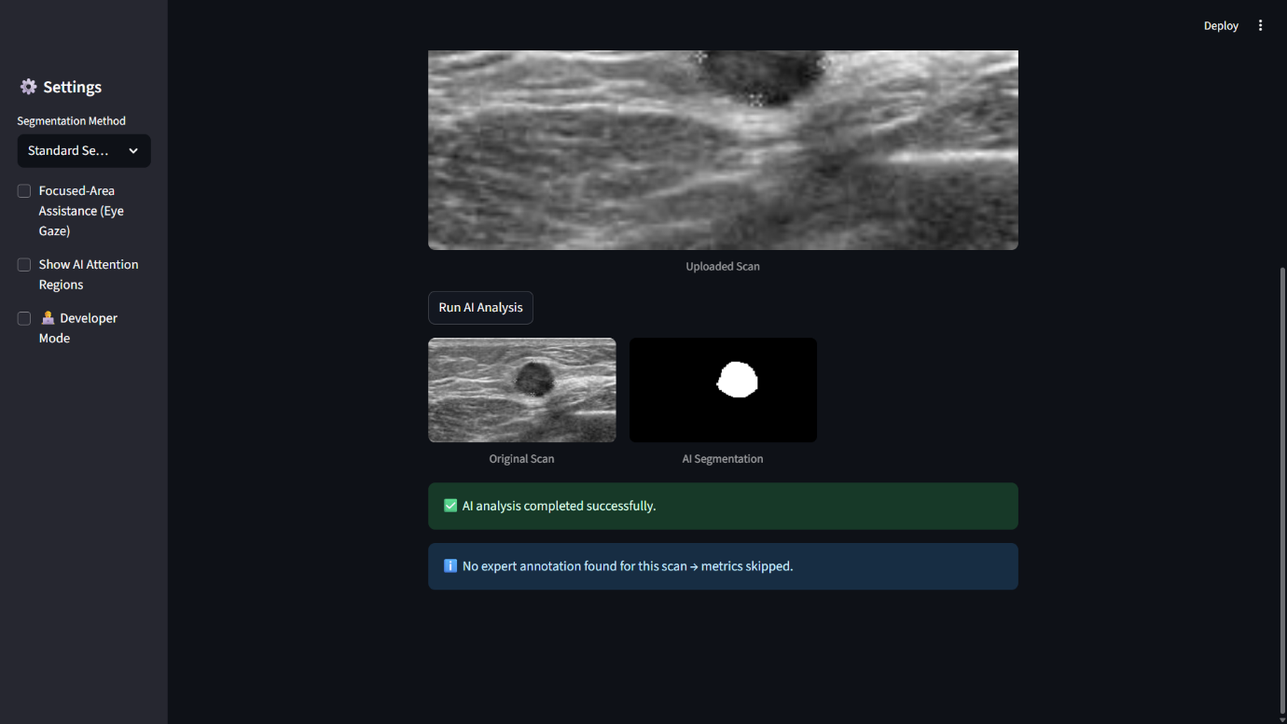

- Fig Real-Time Dashboard (4)
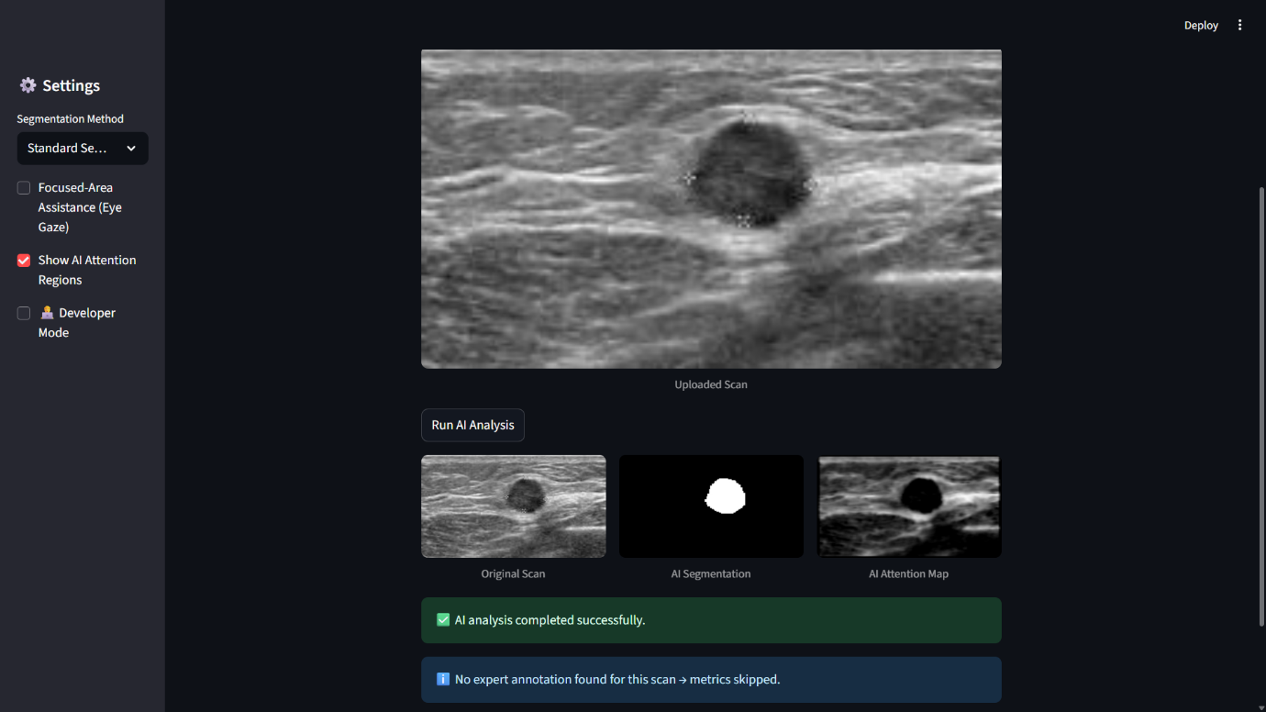

- Fig Real-Time Dashboard (5)
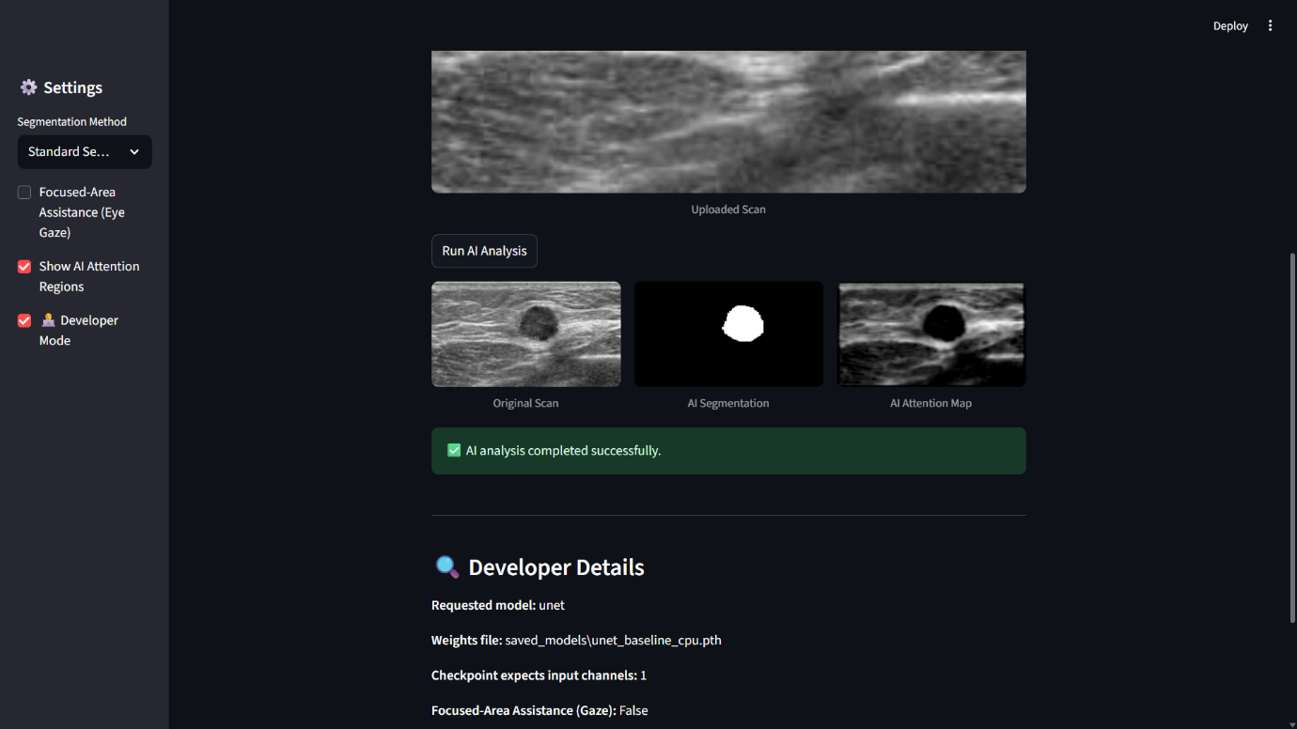

- Github Repository (6)
